

**Release Note Document**

**Learning Management System**

**-**

**G5.FLM**

**Version 1.0**

– Hanoi, July 2023 –

**Table of Contents**

I. Deliverable Package 3

II. Installation Guides 3

III. User Manual 3

1. Overview 3

2. Work flow 3

2.1.User Workflow 3

2.2.Curriculum Workflow 3

2.3.Syllabus Workflow 3

# I. Deliverable Package

| **No.** | **File** | **Notes** |
| --- | --- | --- |
| 1 | mySqlScript.sql | Database, including both table structures and table data |
| 2 | SRS_FLM_G5_SE1709.docx | Final SRS (Requirement) Document |
| 3 | SDS_FLM_G5_SE1709.docx | Final SDS (Design) Document |
| 4 | G5_Project Tracking.xlsx | Final status for the application functions, which include:  - Function name, feature, roles, function description (changes compared to the original requirements are highlighted)  - In Charge, Planned iteration & Actual iteration  - Final status & note on the update you made  - The links to the SRS & SDS are tracked |
| 5 | Issues Report_G5_SE1709.xlsx | Final issues tracking list of the whole project |

Other related deliverables:

* Tagged source codes: <https://gitlab.com/fuhn/summer23/se1709-net_swp391/g5/-/tags/iter4>
* Demonstration video:
* Trúc Hà:
* Iter 4: <https://www.youtube.com/watch?v=aBGJtPuuB5U>
* Update iter1, iter2, iter3: <https://www.youtube.com/watch?v=eODK_gRjgxU>
* Tiến Dũng:
* Iter 4: <https://youtu.be/R0yAi3k7qSM>
* Update iter1, iter2, iter3: <https://youtu.be/hh8aClGQ-J4>
* Văn Thượng:
* Iter 4: <https://youtu.be/T3H63bwlQDc>
* Update iter1, iter2, iter3:<https://youtu.be/1toJZkR6b58>
* Bá Trình:
* Iter4: <https://youtu.be/GXzf5Lzqwcs>
* Update iter1, iter2, iter3: <https://youtu.be/Cw_Rzx5t0zg>

# II. Installation Guides

## 1> Environment install

* JDK 8:[Java Downloads | Oracle](https://www.oracle.com/java/technologies/downloads/#jdk20-windows)

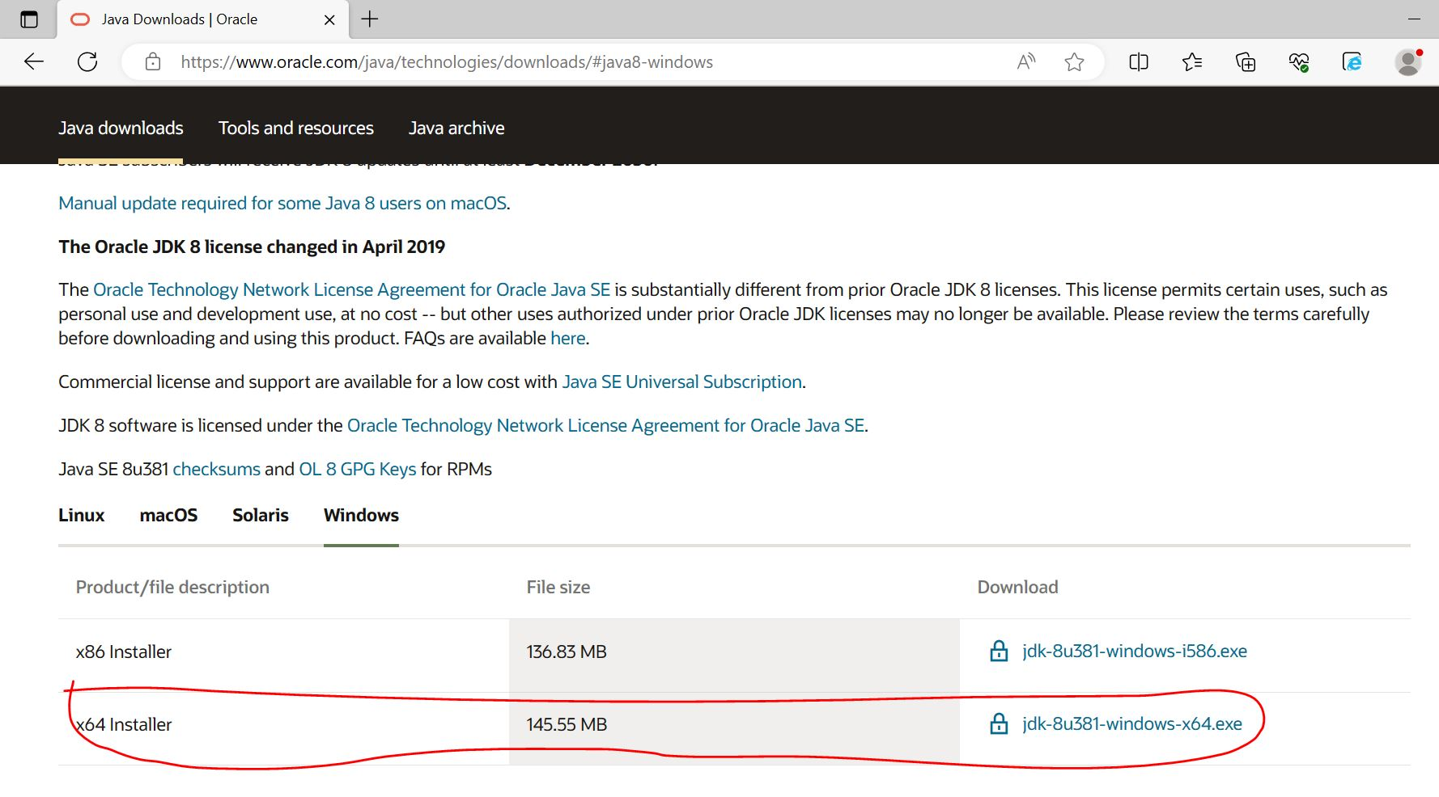

* Apache Tomcat 10.0.18:

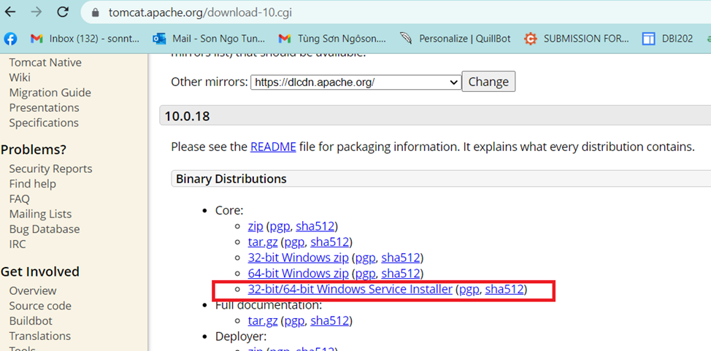

* Apache Netbeans IDE 13: <https://netbeans.apache.org/download/nb13/nb13.html>

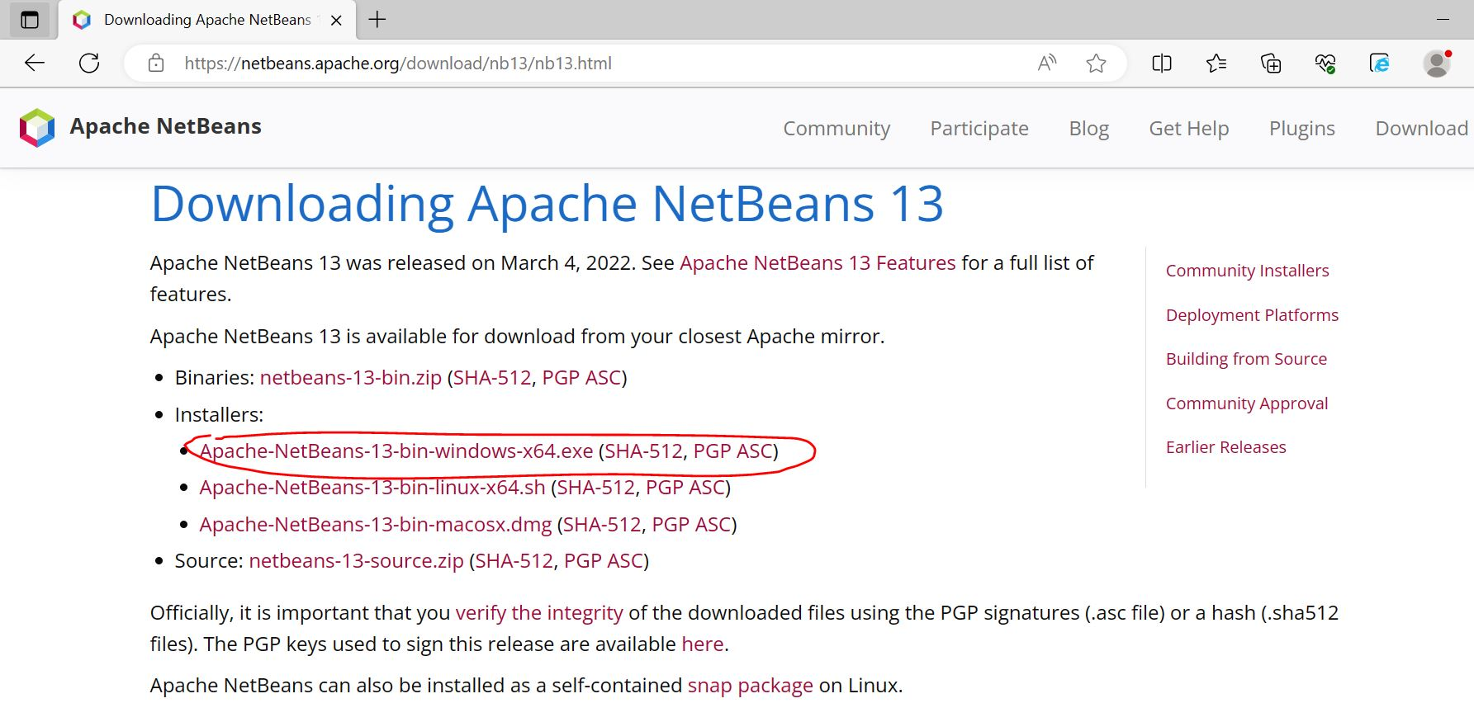

* MySQL :<https://dev.mysql.com/downloads/mysql/>

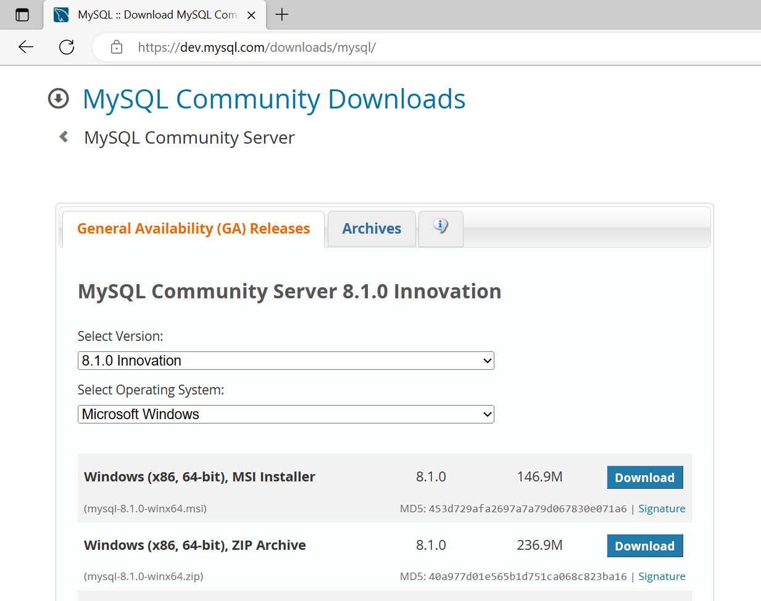

## 2> Database

* Import database MySqlScrip_FLM.sql

## 3> Run code

## Integrating Apache NetBeans IDE 13 with Apache Tomcat.

* Open code using Netbeans 13
* Go to Source Packages/util/Constants – Edit DB_USER_NAME, DB_PASSWORD
* Run

# III. User Manual

## 1. Overview

FLM provides a centralised platform for managing and delivering learning content, making it easy for students and teachers to access the resources they need, and for administrators to manage course materials and track learner progress.

## 2. Workflow

## 2.1. User Workflow

**2.1.1. User Register**

***Actors***: Guests

***Screen/Function Description***: User registration is a process by which individuals create an account or profile on a website, application, or system to gain access to its features, services, or content. The purpose of user registration is to establish a unique identity for each user, enabling personalised interactions and maintaining user-related data securely.

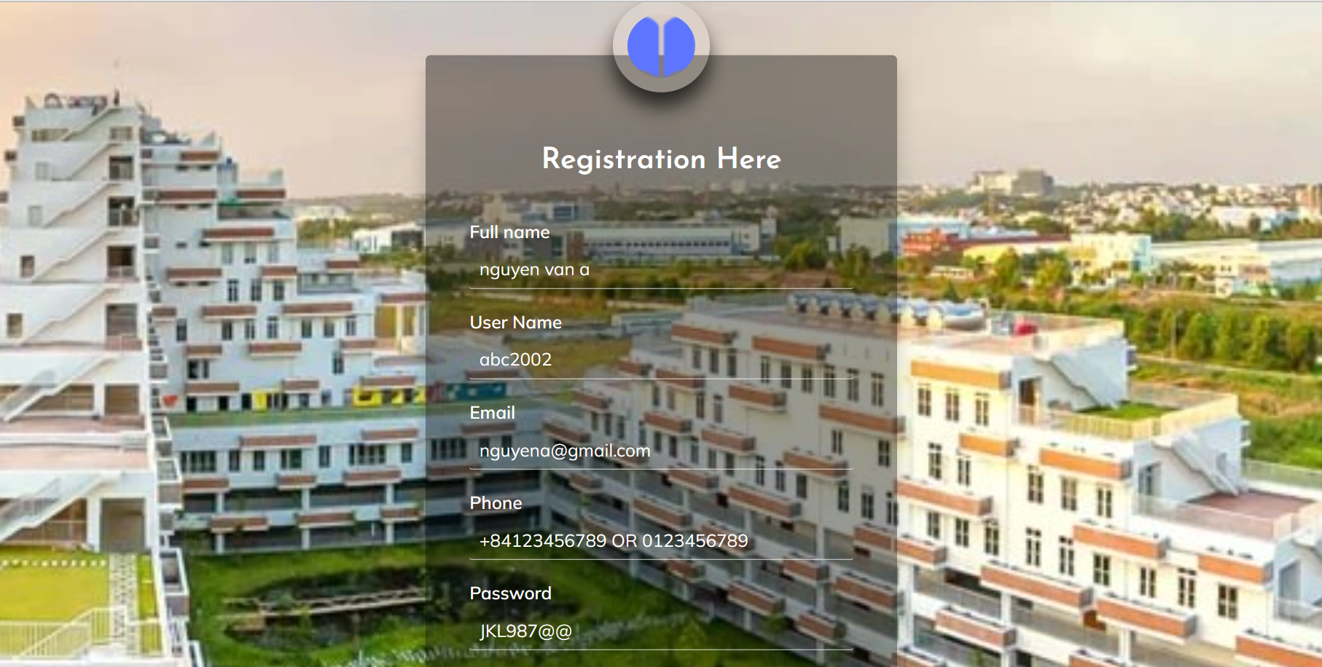

***User Guides***:

* The user accesses the FLM homepage and selects "Register" in the header
* Then enter the necessary information (* pay attention to enter input with correct format)
* After complete fill in blank essential information, click on “Registration” button to create successfully new account

**2.1.2. User Login**

***Actors*:** Student, Teacher, Syllabus reviewer, Syllabus designer, CRDD Staff, CRDD Head, System Admin.

***Screen/Function Description*:** The "Login" section is for everyone, the person who logs in will have a different role when logging in each role after logging in will go to each page according to their role

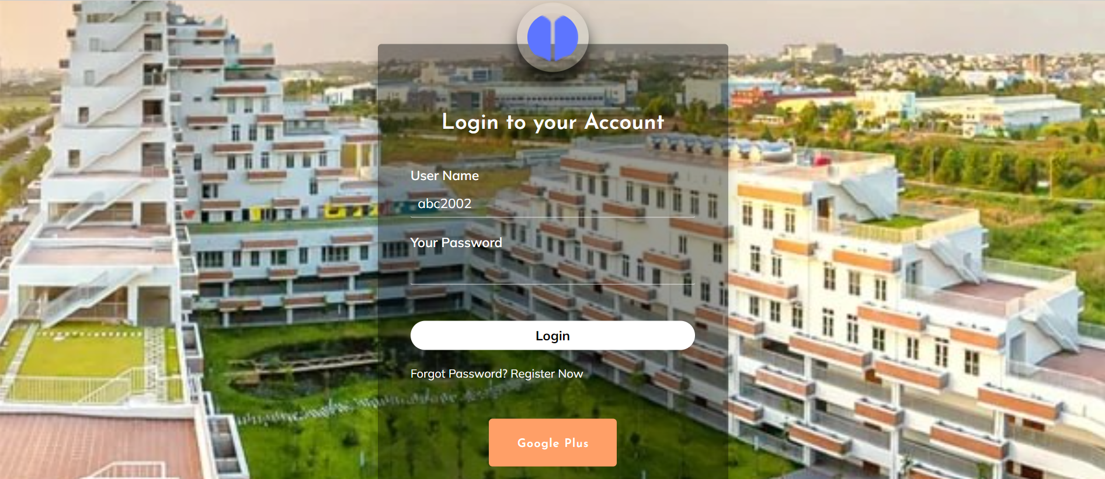

***User Guides*:** After you log in you can not only view but you can see many more things that you can't see if you are not logged in and with each access permission you will have many different functional roles

**2.1.3. Reset password**

***Actors*:** Student, Teacher, Syllabus reviewer, Syllabus designer, CRDD Staff, CRDD Head, System Admin.

***Screen/Function Description*:** The"Reset Password" for everyone who forgot their password can go here to register a new password



***User Guides*:** When you forget your password, you go here to create a new password, but it requires you to have the correct gmail account or phone number when registering for an account because it sends a code to confirm then you can create a new password.

**2.1.4. User Profile**

***Actors*:** Student, Teacher, Syllabus reviewer, Syllabus designer, CRDD Staff, CRDD Head, System Admin.

***Screen/Function Description*:** The user profile function is a function that allows an account to view its information and can edit it.

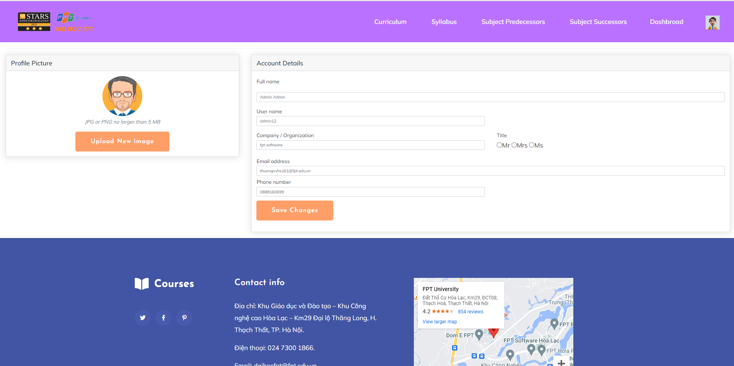

***User Guides*:** When you want to change something in your profile, you can access the User profile in the header bar and then display the information you want to change. When you are done making changes, you need to click the save button to be able to change the values you just entered.

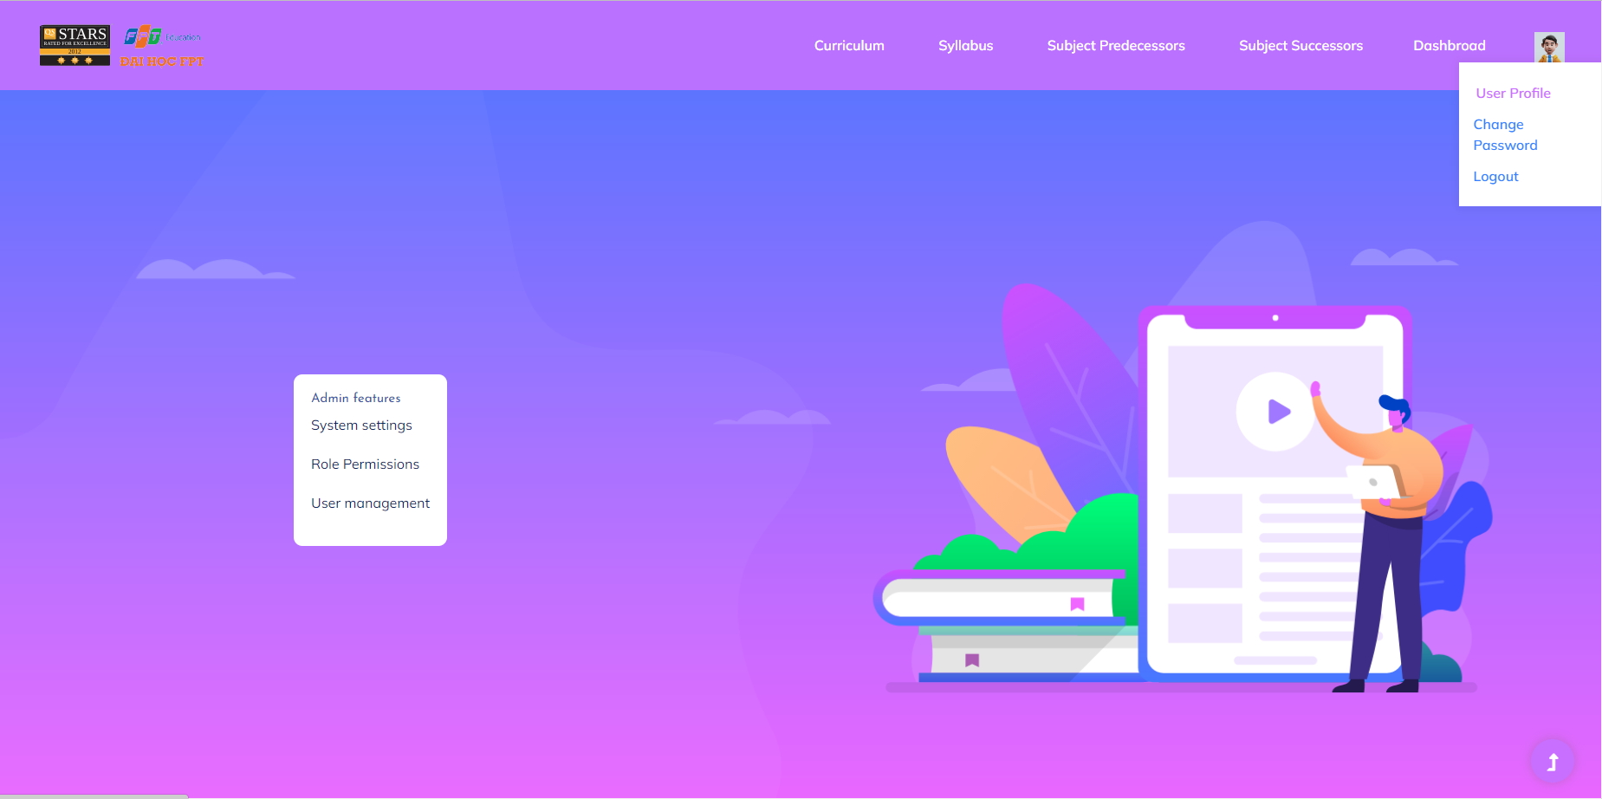

**2.1.5. Change Password**

***Actors***: Student, Teacher, Syllabus reviewer, Syllabus designer, CRDD Staff, CRDD Head, System Admin.

***Screen/Function Description***:Password change function is a function that allows users to change password information when they want to change another password.

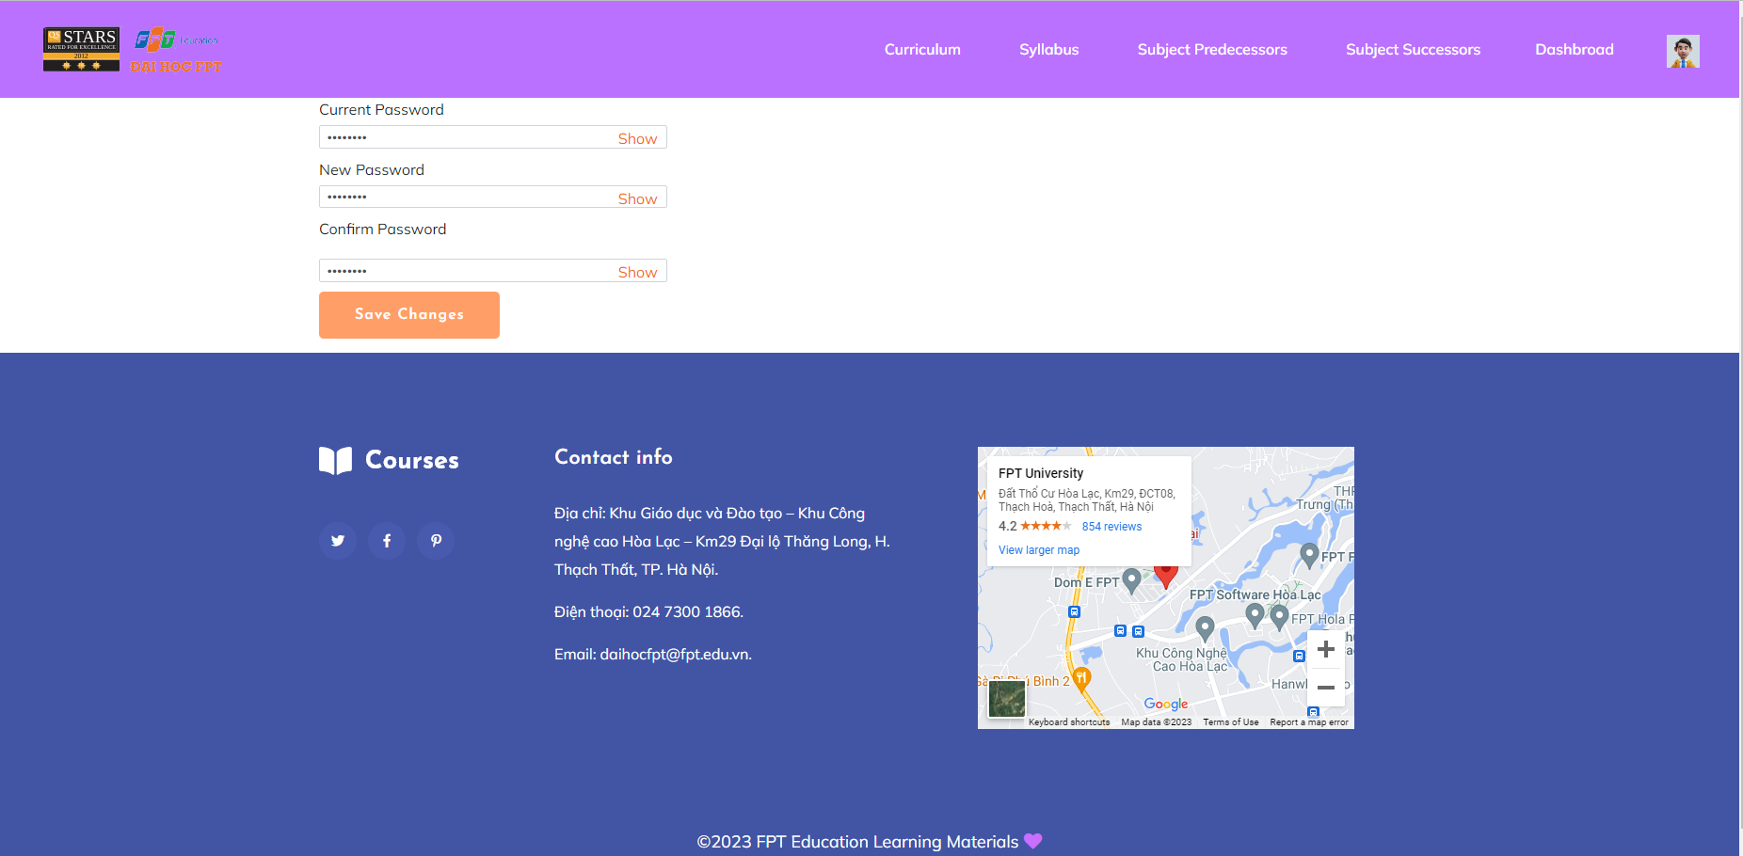

***User Guides***:When you want to change the password you need to go to the header to find the password change section. In which, when using you need to enter the correct old password and must not enter the same old password with the new password and the new password must match the re-authentication password. Then users just need to click on save change, they can update the password if there is an error, it will be notified, and if the update is successful, it will notify and logout the user to log out again.

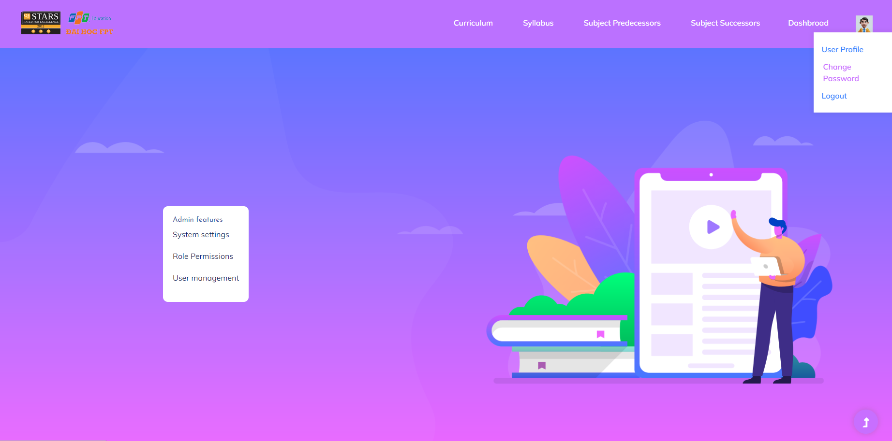

**2.1.6. Account List**

***Actors***: System Admin

***Screen/Function Description***: The "Account List" feature for a system administrator is a functionality that allows the admin to view and manage user accounts within a system or application. This feature is essential for overseeing user access, permissions, and activity, ensuring the security and proper functioning of the system.

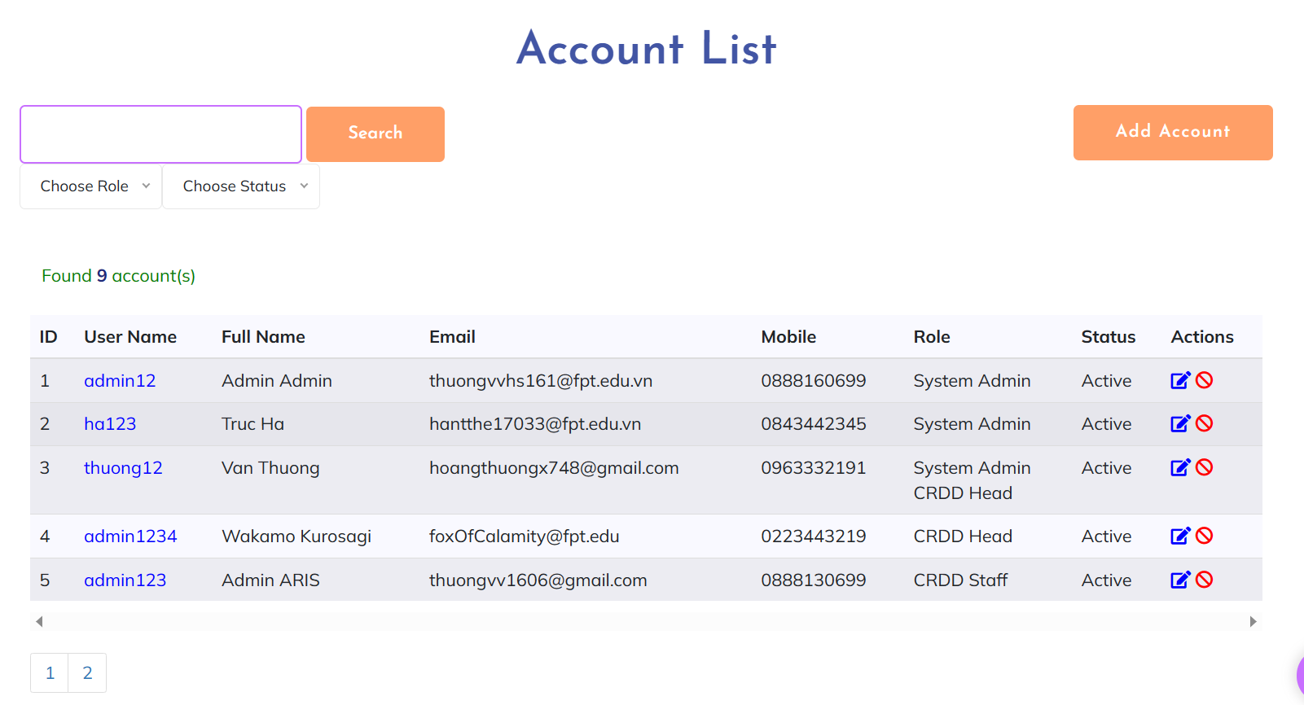

***User Guides***:

* After sign in FLM with account has role System Admin, user choose “User management” (System Admin features) on the home screen

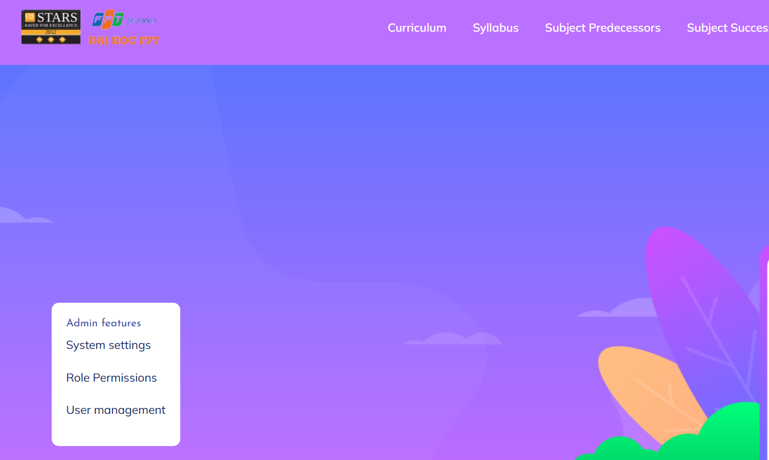

* After that, system admin can perform different operations on this screen: sort account by ID; filter (by status, assignee), search for account; activate/deactivate account

**2.1.7. Account Detail**

***Actors***: System Admin

***Screen/Function Description***: The "Account Detail" feature on the account list for a system administrator provides comprehensive information about a specific user account. When the system administrator clicks on an individual user account from the account list, the "Account Detail" view is displayed, offering in-depth information and management options for that particular user.

This feature contains Add New Account and Edit Account:

* Add New Account:

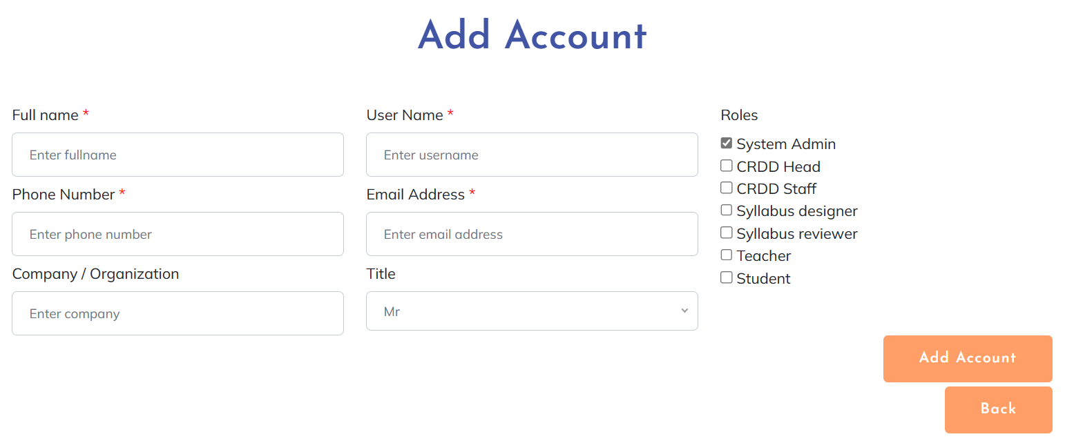

* Edit Account:

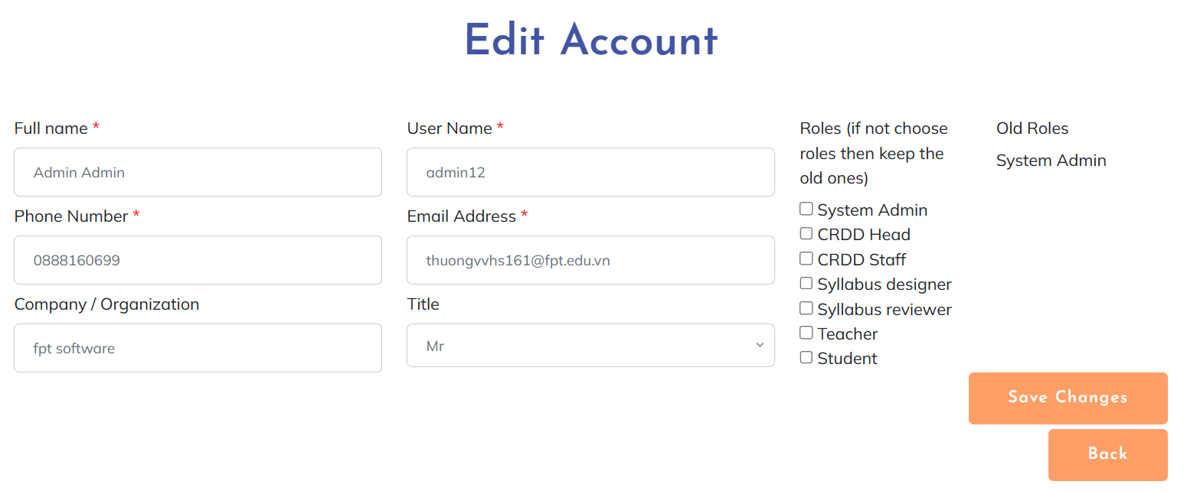

***User Guides***:

* Add New Account:
* From Account List screen, admin click on “Add Account” button
* After accessing the “Add account” screen, admin fill in blank information for new account then click “Add Account” button to finish
* The password for the new account will be randomly generated and send to email after creating successfully
* Edit Account:
* From Account List screen, admin click on “Edit” symbol button in the same row as the account he/she wants to edit
* After accessing the “Edit account” screen, the admin updates information that needs to change, then clicks the “Save changes” button to update information successfully. If they don’t need to edit this account, click the “Back” button to go back to the Account List without changing the account details.

**2.1.8. Setting List**

***Actors***: System Admin

***Screen/Function Description***: The "Setting List" feature for a system administrator is a functionality that allows the admin to view and manage system setting.

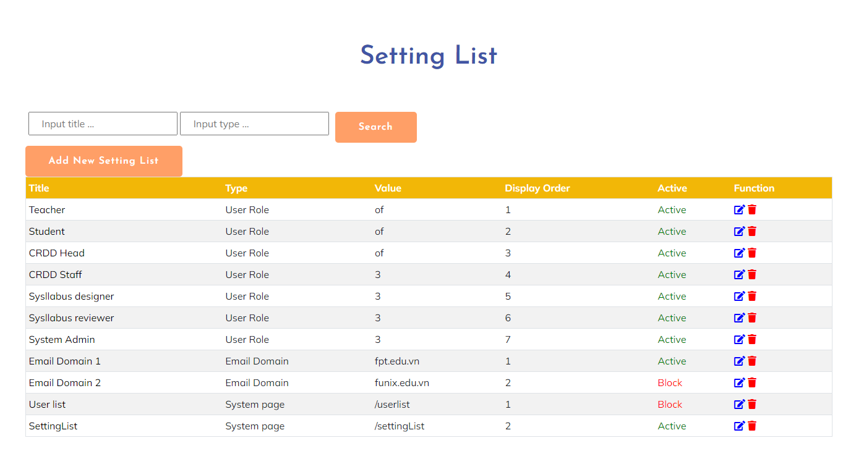

***User Guides***:

- After sign in FLM with account has role System Admin, user choose “System settings” (System Admin features) on the home screen



- After that, system admin can perform different operations on this screen: search for setting; active/block setting

**2.1.9. Setting Detail**

***Actors***: System Admin

***Screen/Function Description***: The "Setting Detail" feature on the account list for a system administrator provides comprehensive information about a specific system account. When the system administrator clicks on an individual system account from the system list, the "Setting Detail" view is displayed, offering in-depth information and management options for that particular user.

This feature contains Add New Setting, Edit Setting, Detail Setting:

* Detail Setting

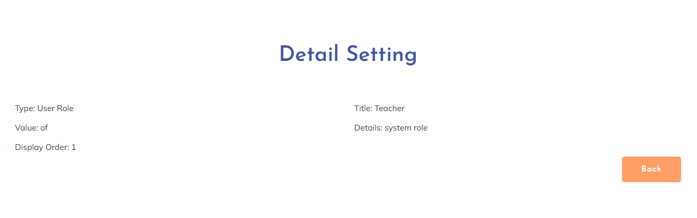

* Add New Setting

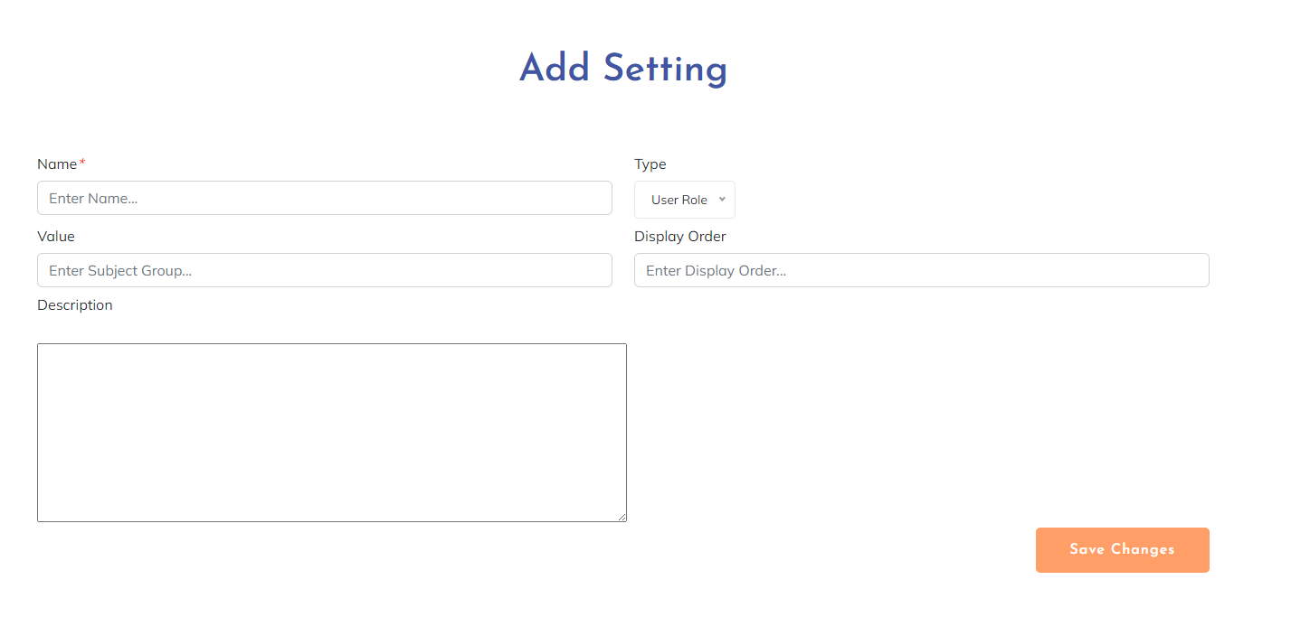

* Edit Setting

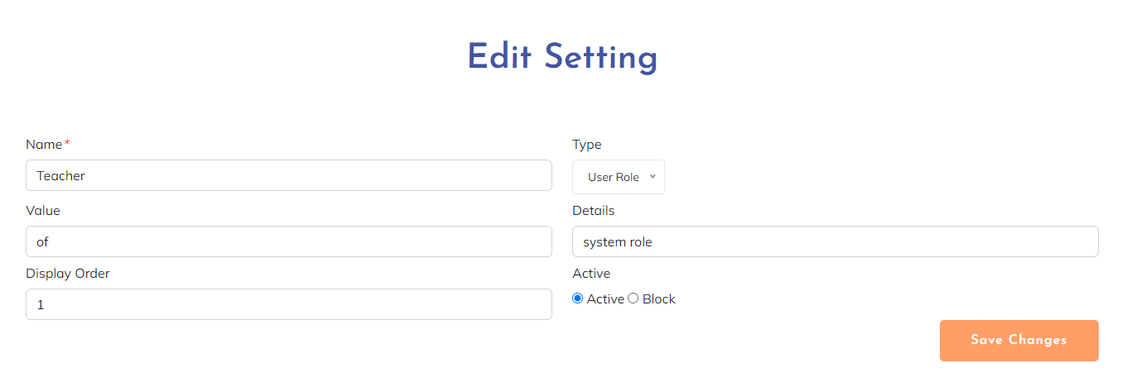

***User Guides***:

* Detail Setting
* From Setting List screen, the admin clicks on the “title” name in the same row as the account he/she wants to view. After viewing, click the “Back” button to go back to Setting List.
* Add New Setting
* From Setting List screen, admin click on “Add New Setting List” button
* After accessing the “Add setting” screen, admin fill in blank information for new account then click “Save changes” button to finish
* Edit Setting
* From Setting List screen, admin click on “Edit” symbol button in the same row as the account he/she wants to edit
* After accessing the “Edit setting” screen, the admin updates information that needs to change then clicks the “Save changes” button to update information successfully. If they don’t need to edit this setting, click the “Back” button to go back to SettingList without changing the setting details.

## 2.2. Curriculum Workflow

**2.2.1. Curriculum List**

***Actors***: All FLM user

***Screen/Function Description***: A "Curriculum List" is a structured and organised compilation of all the curricula or educational programs offered by an educational institution, training centre, or online learning platform. It serves as a comprehensive inventory of the available courses and learning pathways, providing essential information about each curriculum to prospective students, educators, administrators, or any stakeholders involved in the educational process.

* Screen as guest or login with normal role:

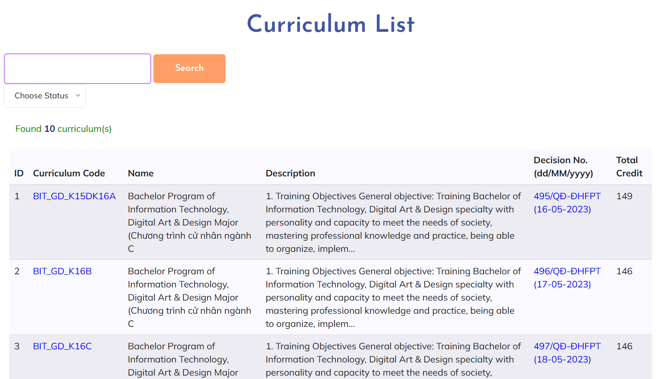

* Screen after login with staff role:

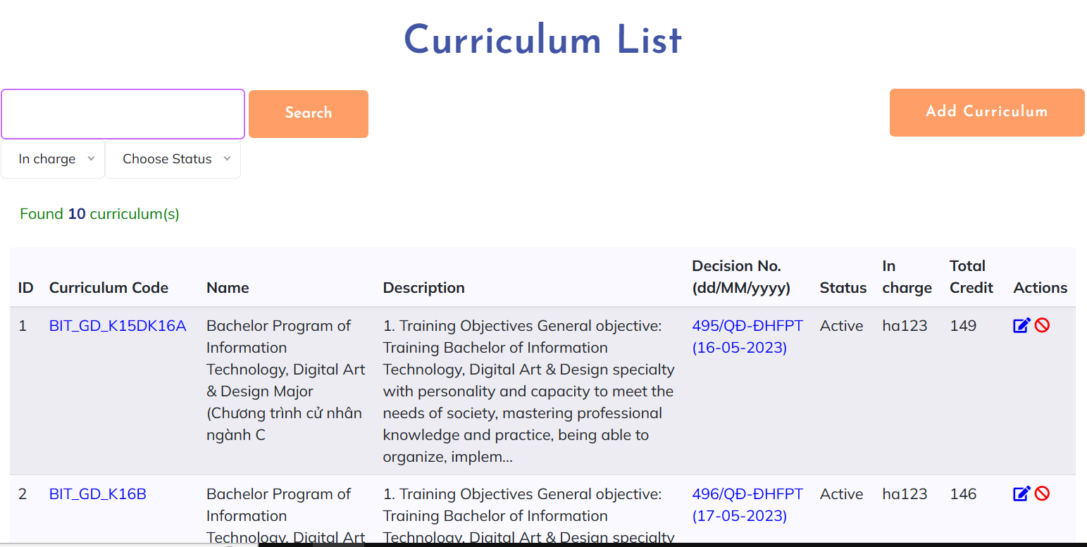

***User Guides***:

* User access FLM website then click on “Curriculum” on page header
* On this screen, user can view, search, filter for curriculum. For some certain role, they can activate, deactivate curriculum and have the path to add or edit curriculum from this screen.

**2.2.2. New Curriculum**

***Actors***: CRDD Head, CRDD Staff, System Admin

***Screen/Function Description***: The “New Curriculum”, Administrator can add a new curriculum to the list of curriculum

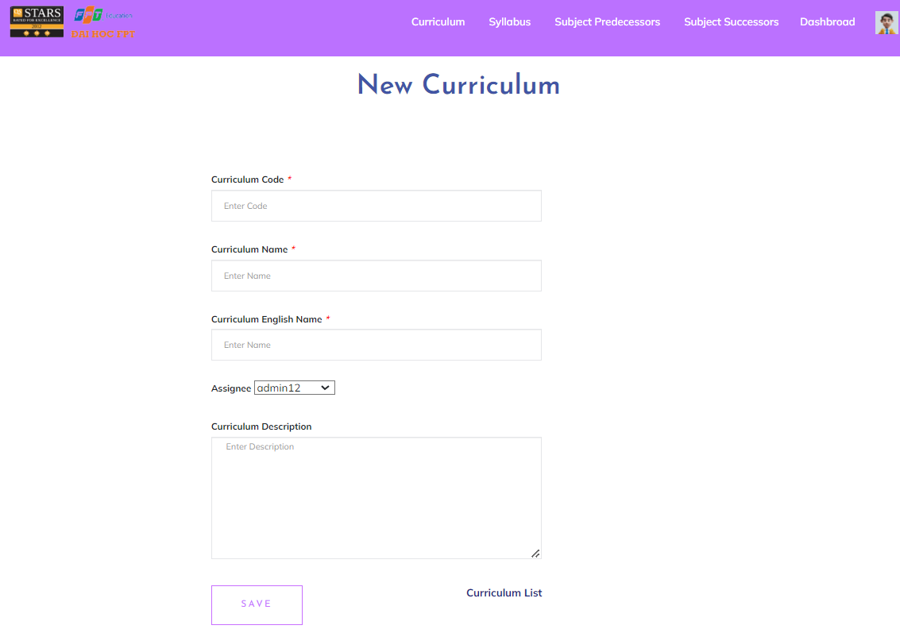

***User Guides***: Only the administrator after login has the right to new curriculumOnly the administrator after login has permission to new curriculum, after successfully created it will display in the curriculum list

**2.2.3. Curriculum Overview**

***Actors***: All FLM Users

***Screen/Function Description***: The "Curriculum Overview" feature provides a comprehensive and concise view of an entire curriculum or educational program. It allows users to understand the structure, content, and learning outcomes of the curriculum at a glance.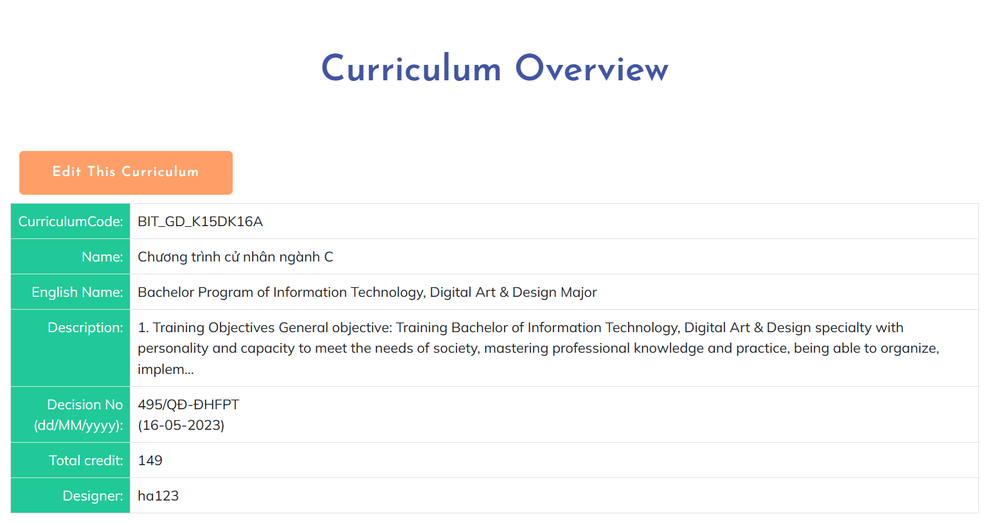

***User Guides***: User access FLM website then click on “Curriculum” on page header, then click on code of curriculum they want to view detail to see overview

**2.2.4. Curriculum Edit**

***Actors***: CRDD Head, CRDD Staff, System Admin

***Screen/Function Description***: The Curriculum Edit feature allows administrators to change or update the curriculum they want to implement.

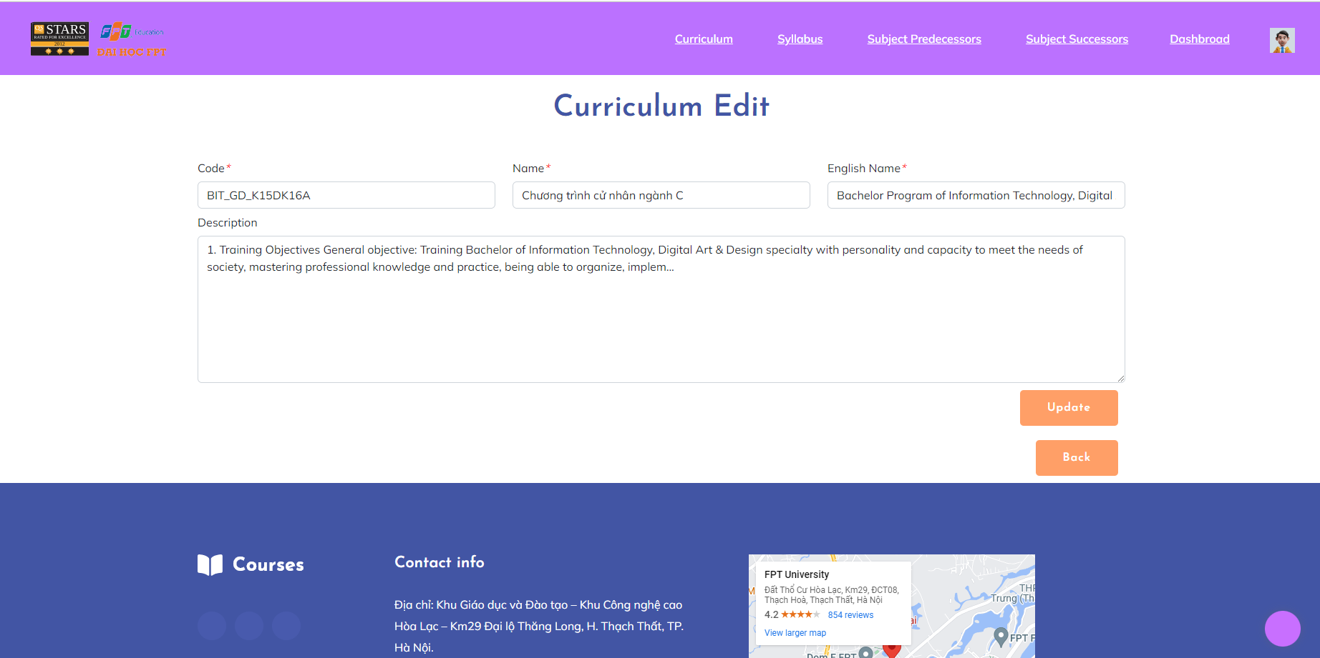

***User Guides***: When the administrator clicks on the edit button in the action column, there will be an interface where they can change the values they want to change and they will have to enter all the information in it and then click the Update button if the update is successful, it will return to the list page and display a message, otherwise it will stay on the edit page and display an error message.

**2.2.5. Subject List**

***Actors***: CRDD Staff

***Screen/Function Description***: A "Subject List" is a structured and organised compilation of all subjects of a learning platform.

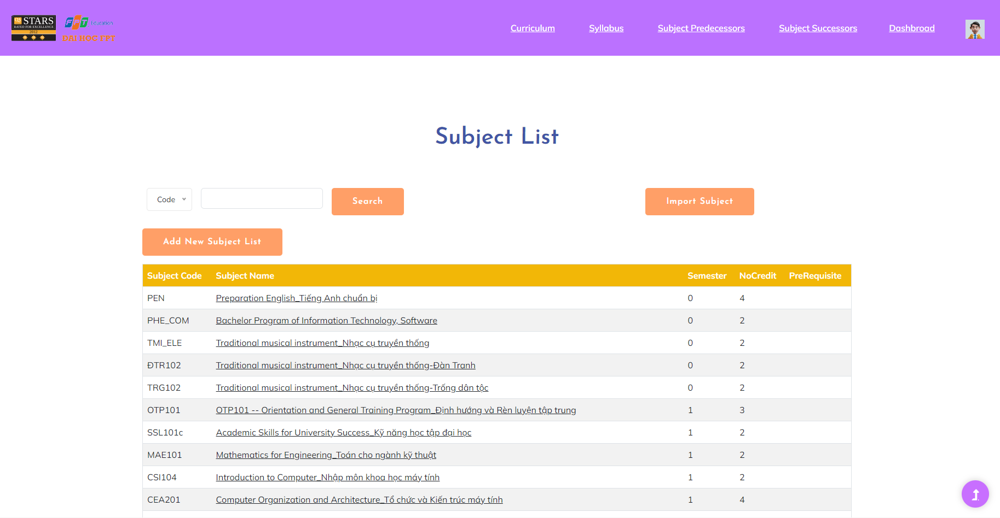

***User Guides***:

* After sign in FLM with account has role CRDD Staff, System Admin, user choose “Manage Subjects” (CRDD staff features) on the home screen

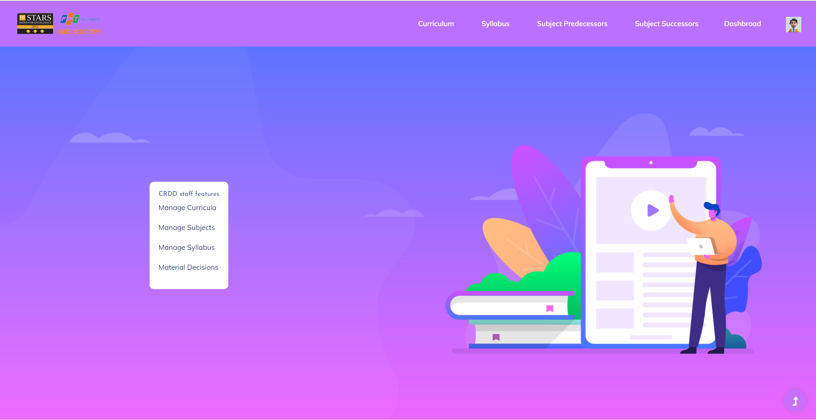

* After that, system admin can perform different operations on this screen: the admin to search subject by code or name, import subject, add new subject

**2.2.6. New Subject**

***Actors***: CRDD Staff

***Screen/Function Description***: The admin can add new subjects.

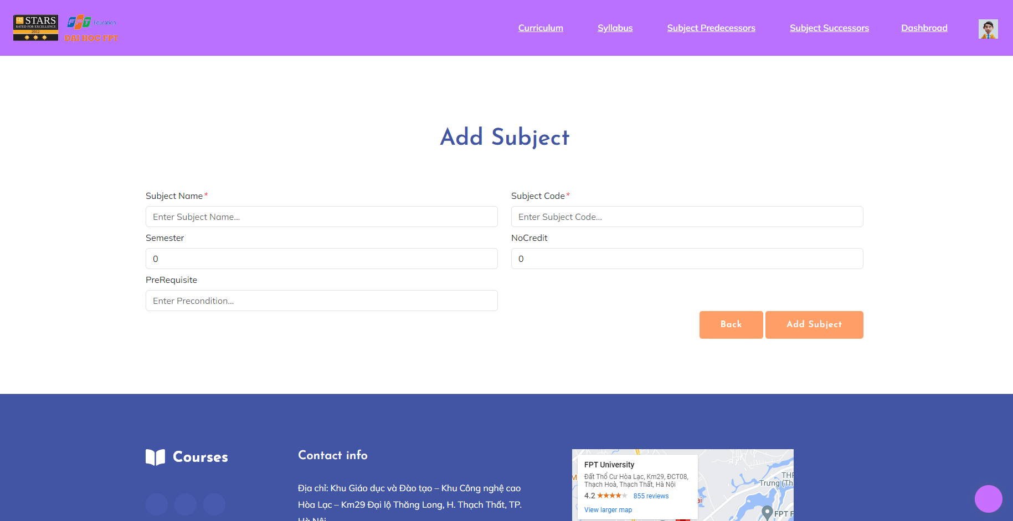

***User Guides***:

* From Subject List screen, admin click on “Add New Subject List” button
* After accessing the “Add subject” screen, the admin fills in blank information for the new subject then clicks the “Add Subject” button to finish. If they don’t need to add a subject, click the “Back” button to go back to the Subject List.

**2.2.7. New Curriculum Subject**

***Actors***: CRDD Staff, System Admin

***Screen/Function Description***: The admin can add new subjects to the Curriculum

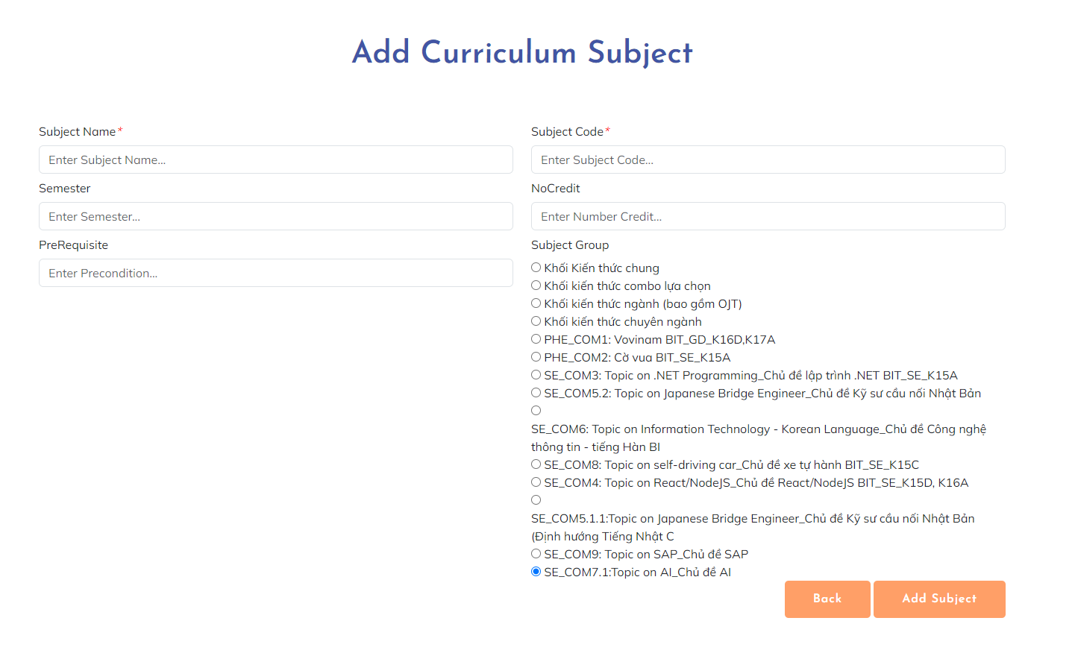

***User Guides***:

* From Curriculum Subject List screen, admin click on “Add New Curriculum Subject” button
* After accessing the “Add Curriculum Subject” screen, the admin fills in blank information for the new curriculum subject then clicks the “Add Subject” button to finish. If they don’t need to add a subject, click the “Back” button to go back to the Curriculum Subject List.

**2.2.8. Subject Import**

***Actors***: CRDD Staff, System Admin

***Screen/Function Description***: The “Subject Import”, download the subject template and can add data from excel into the system into the subject table

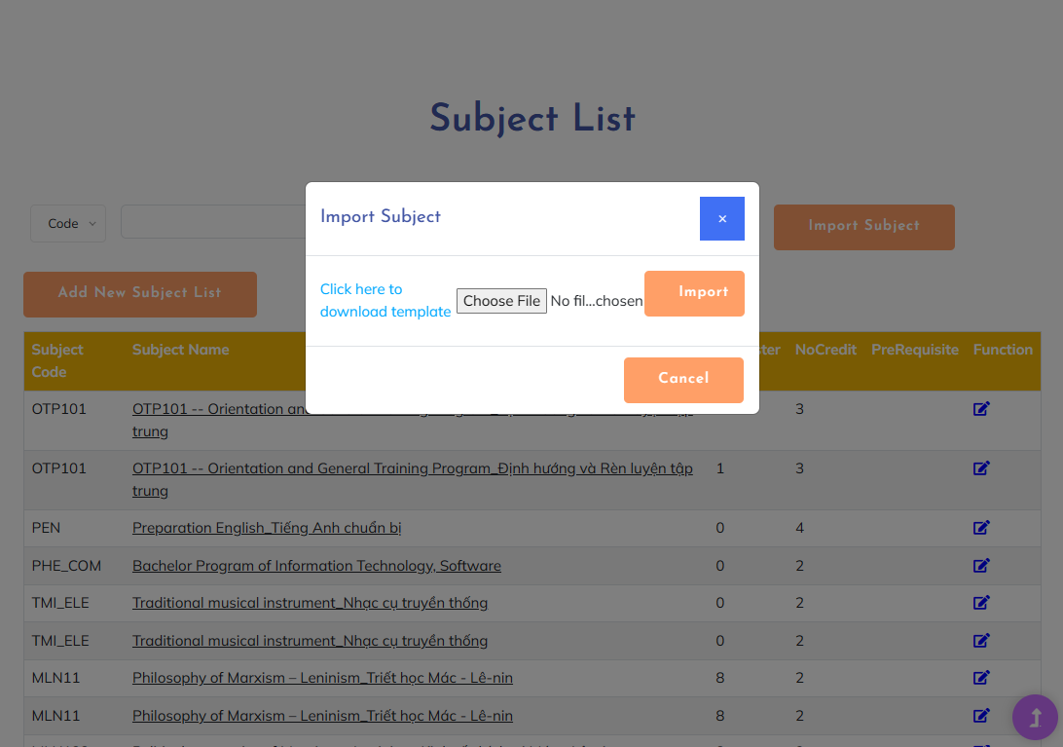

***User Guides***: Only managers or staff can download the subject template and can add data from excel into the system into the subject table

**2.2.9. Subject -PLO Mapping**

***Actors***: All FLM user

***Screen/Function Description***: The Subject - PLO Mapping function helps to identify the relationship between specific learning objectives (PLOs) and subject.

* Screen after login with staff role:

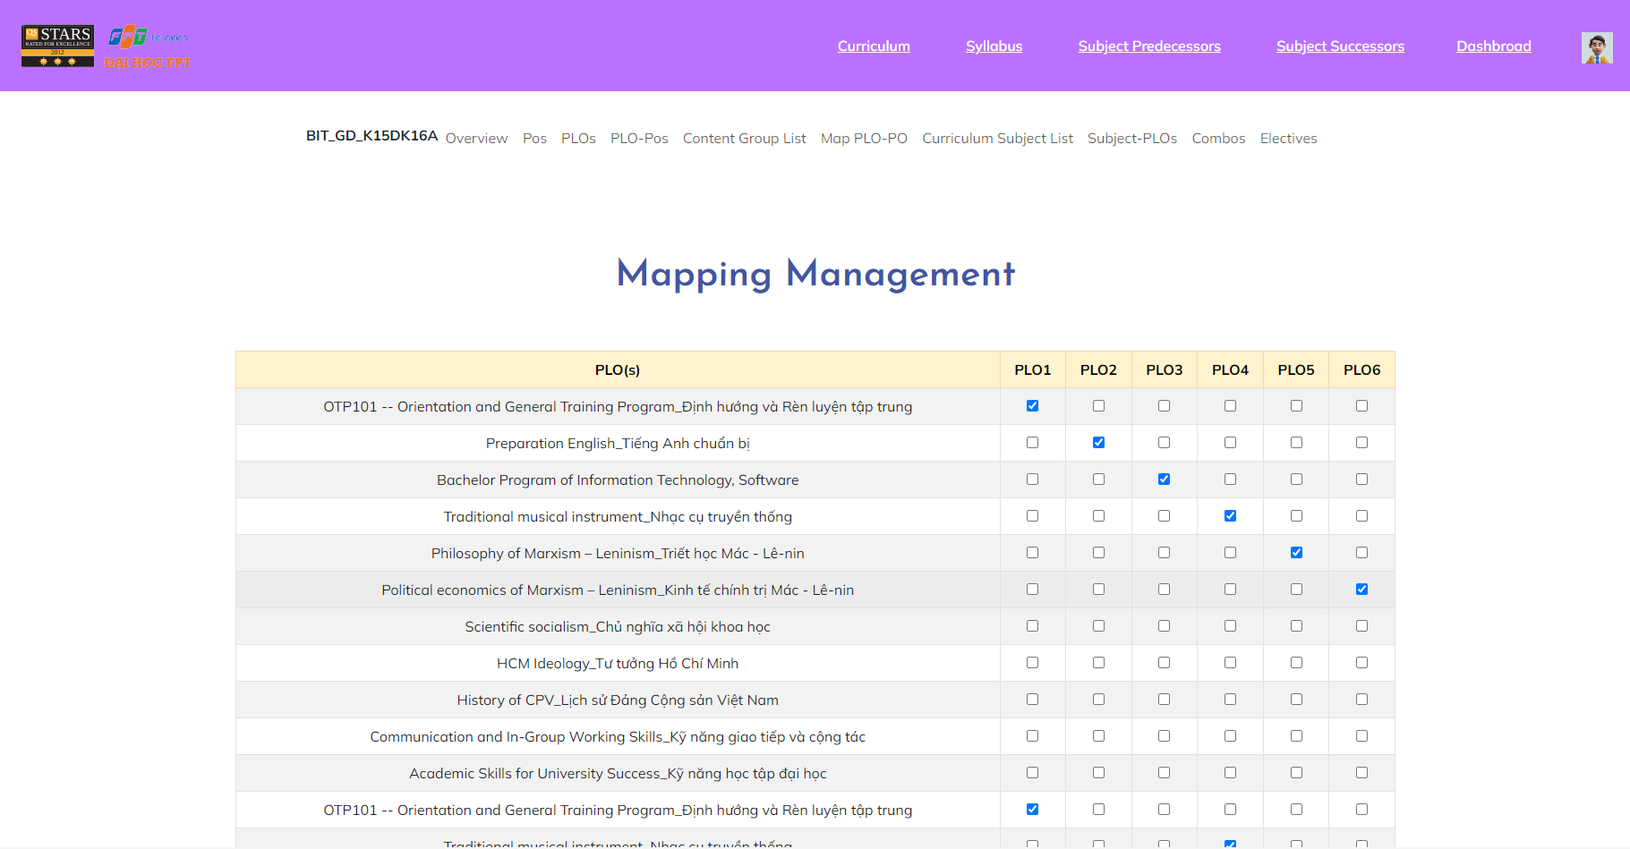

* Screen as guest or login with normal role:

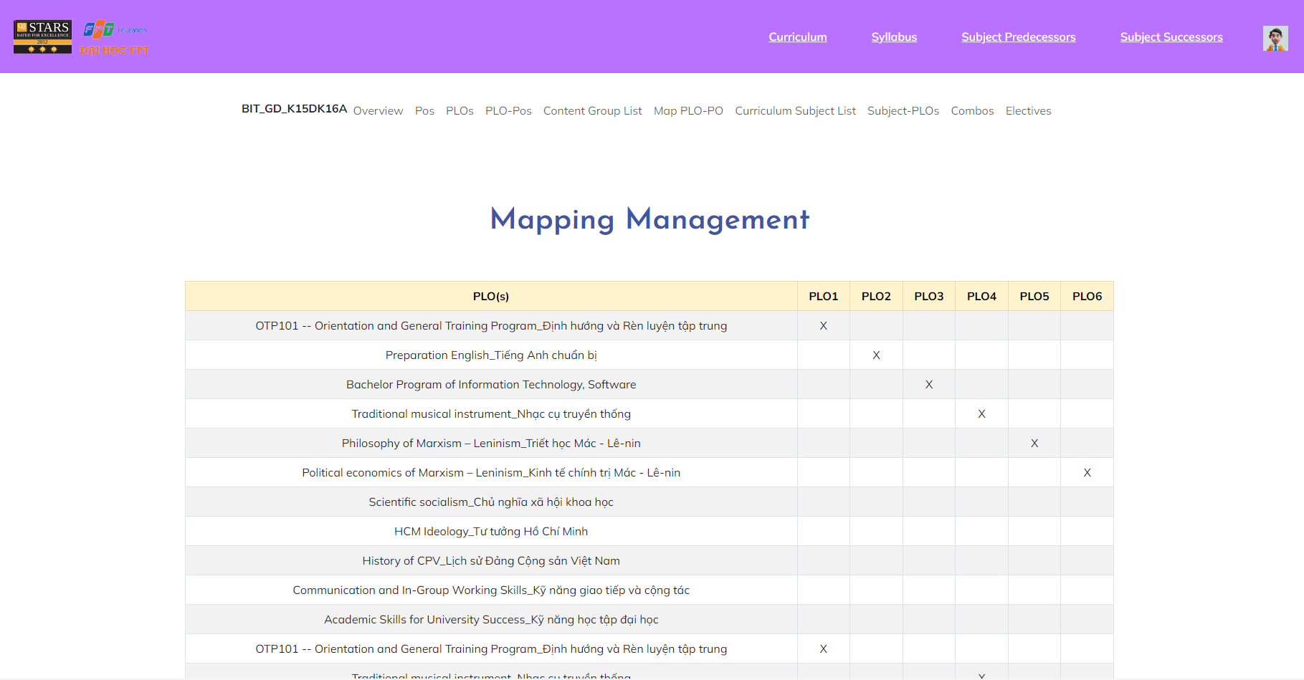

***User Guides***:

* The Subject - PLO mapping function helps to identify the relationship between specific learning objectives (PLOs) and subject.
* To access a Subject - PLO mapping, the user must directly access a Curriculum and will display the navigation toolbar with the keyword PLOs, then click on "Subject - PLOs", the user will see the map lists with that x.

**2.2.10. Curriculum Subject Details**

***Actors***: All FLM user

***Screen/Function Description***: The "Curriculum Subject Details" feature in the Curriculum Subject list provides comprehensive information about a particular subject in the curriculum. When users click on a subject from the list of subjects in the curriculum, an "Curriculum Subject Details" view is displayed, providing insights for all users.

This feature containsCurriculum Subject Details for all users and Edit Subject for admin:

* Curriculum Subject Details

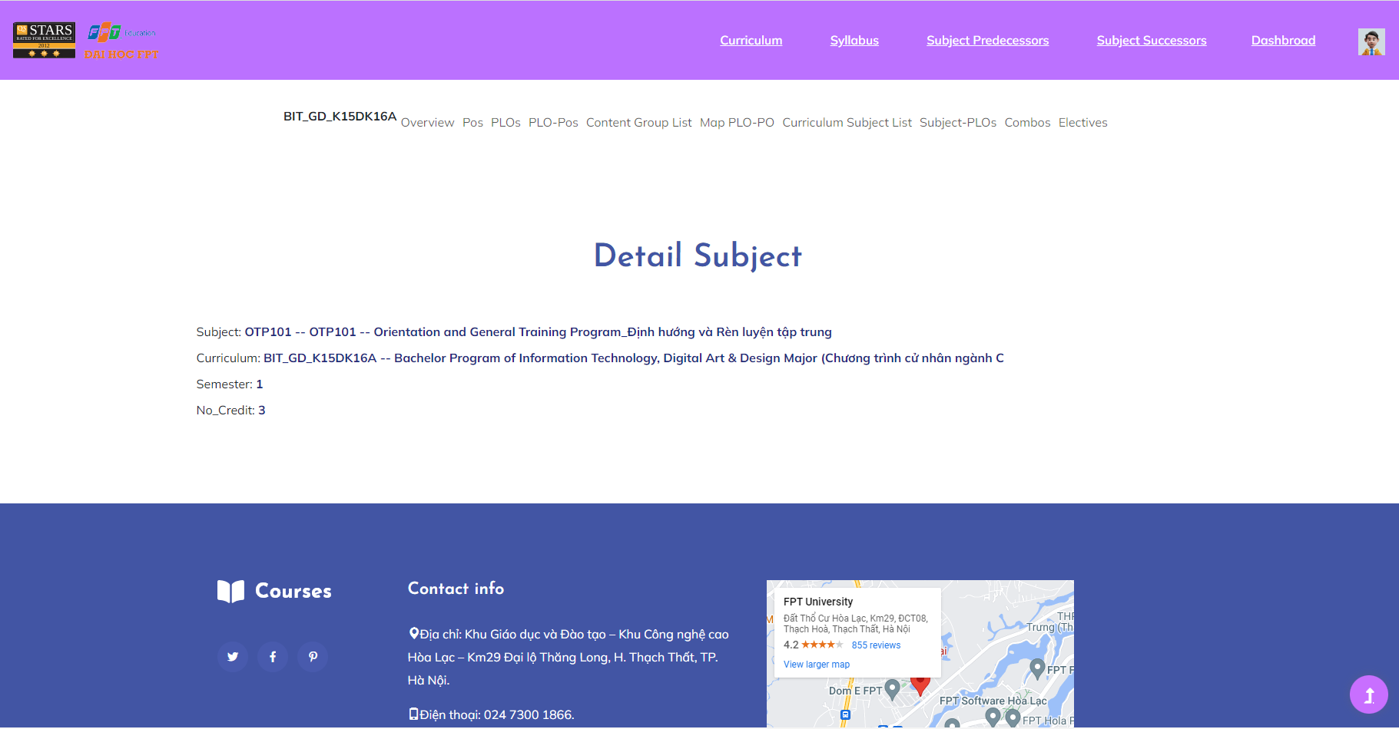

* Edit Subject

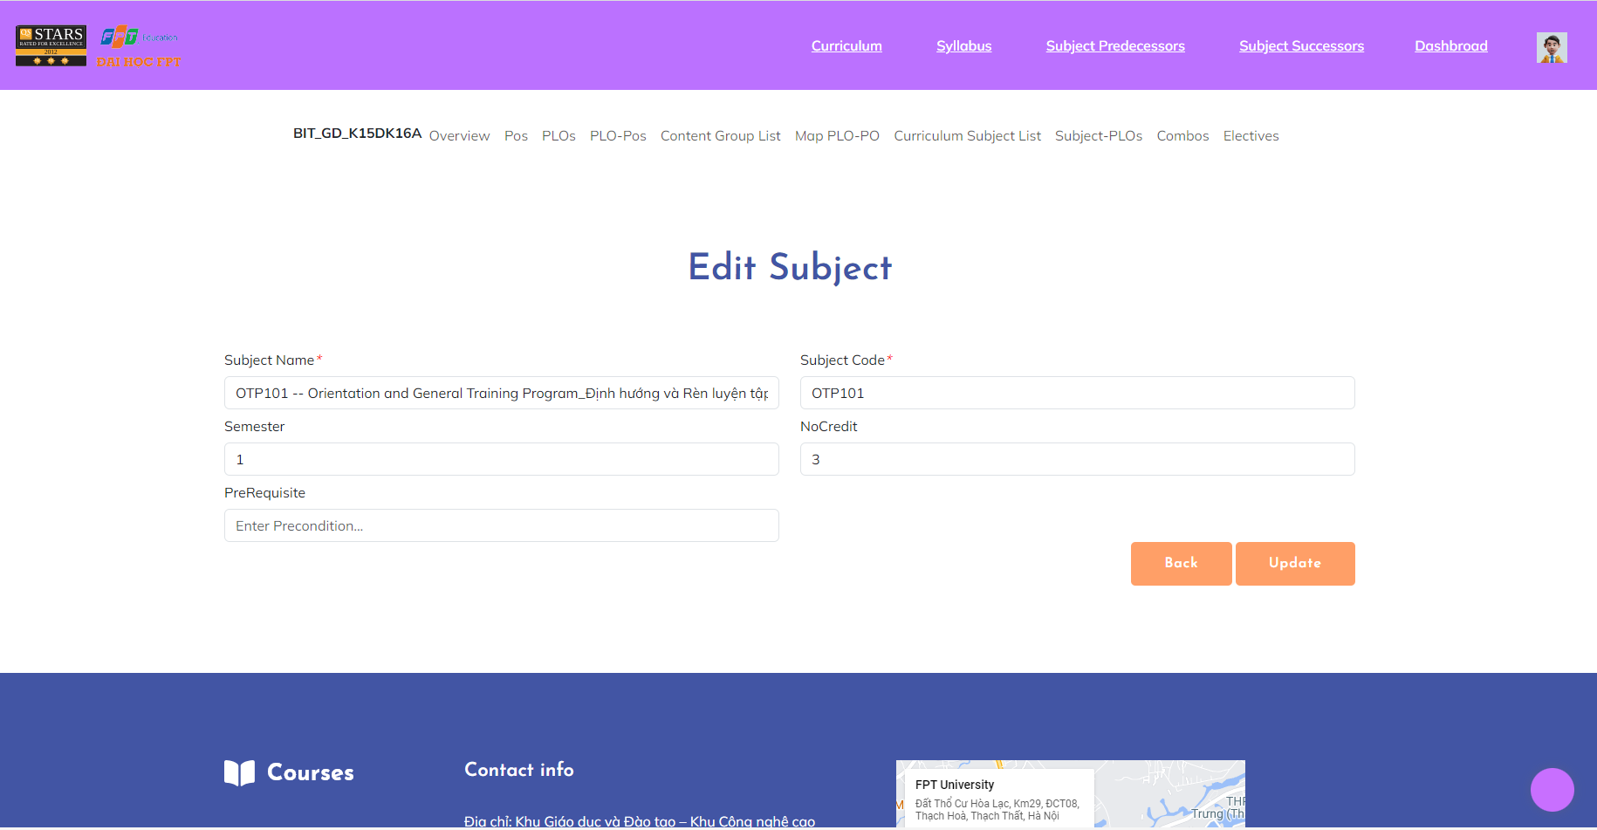

***User Guides***:

* Curriculum Subject Details
* From the Curriculum Subject List screen, the admin clicks on the “title” name in the same row as the account he/she wants to view. After viewing, click the “Back” button to go back to Curriculum Subject List.
* Edit Subject
* From Curriculum Subject List screen, admin click on icon in the Function column symbol button in the same row as the account he/she wants to edit
* After accessing the “Edit subject” screen, the admin updates information that needs to change then clicks the “Update” button to update information successfully. If they don’t need to edit this curriculum subject, click the “Back” button to go back to Curriculum Subject List without changing the Curriculum Subject details.

**2.2.11. Subject Details**

***Actors***: All FLM user

***Screen/Function Description***: The "Subject Details" feature in the Subject list provides comprehensive information about a particular subject. When users click on a subject from the list of subjects, an "Subject Details" view is displayed, providing insights for all users.

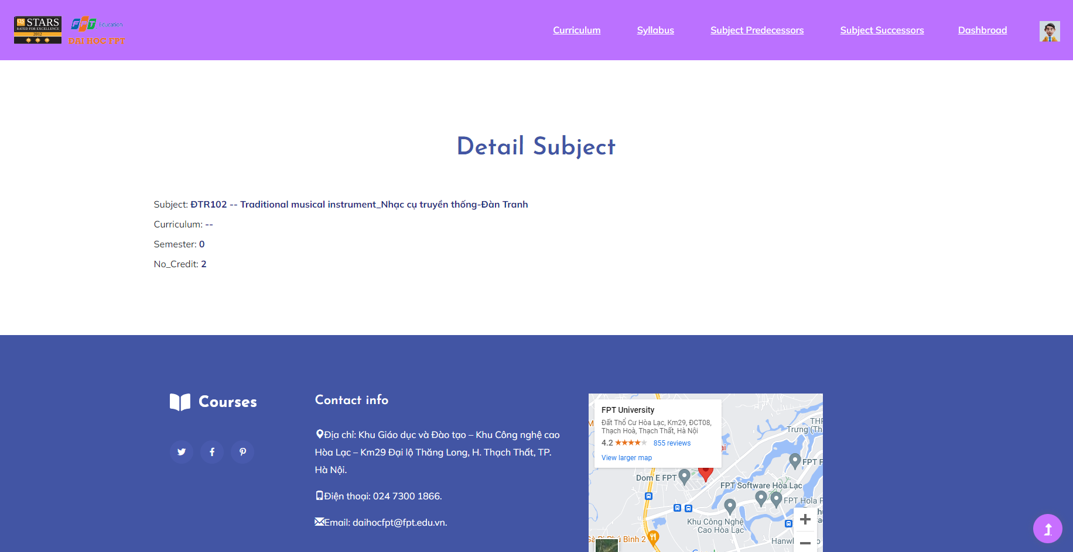

***User Guides***:

* From the Subject List screen, the admin clicks on the “title” name in the same row as the account he/she wants to view.

**2.2.12. Subject Predecessors**

***Actors***: All FLM user

***Screen/Function Description***:The "Subject Predecessors" will display the syllabus of that subject and display the pre-conditional subjects to be able to study this subject.

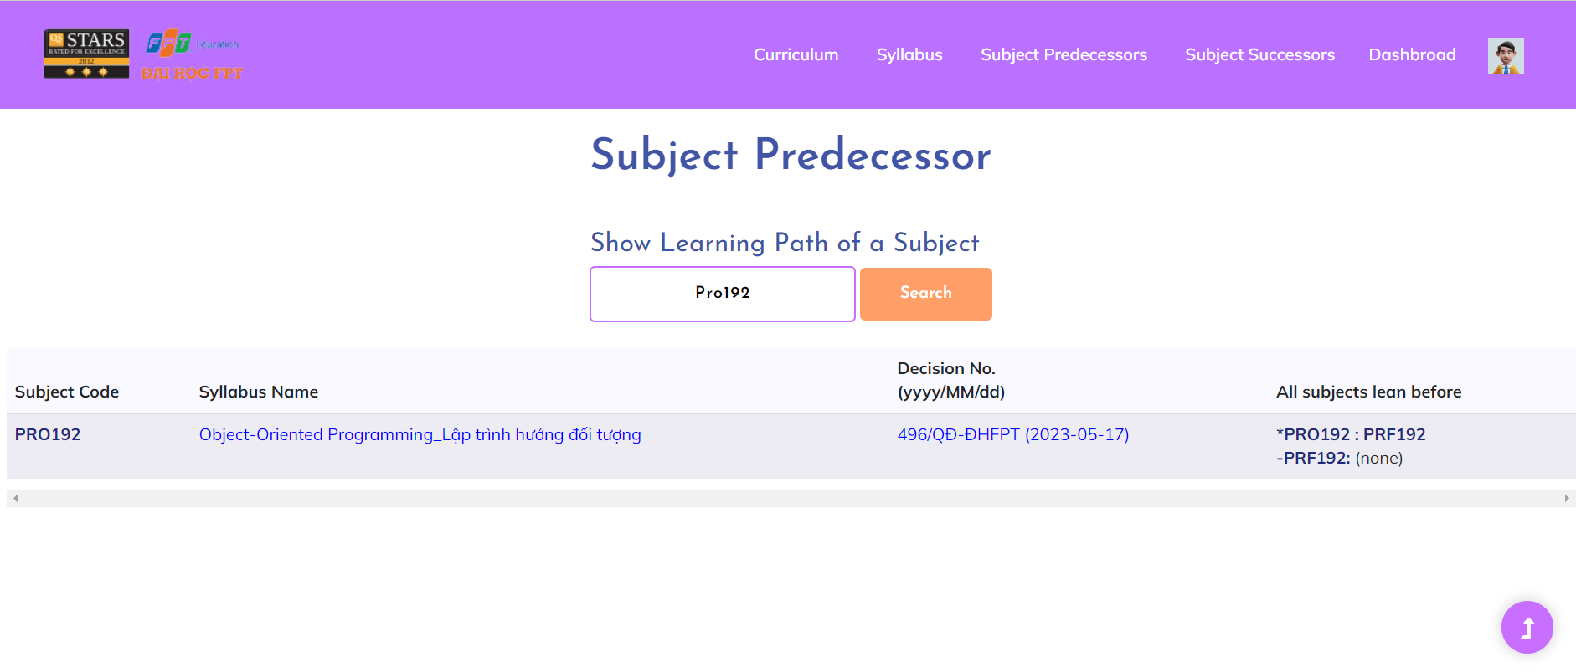

***User Guides***: After the user searches for a certain subject, it will display the curriculum and display the necessary subjects to be able to study this subject.

**2.2.13. Subject Successors**

***Actors***: All FLM user

***Screen/Function Description***: The "Subject Successor" section will display the syllabus of that subject and display the subjects that will be studied after completing this course.

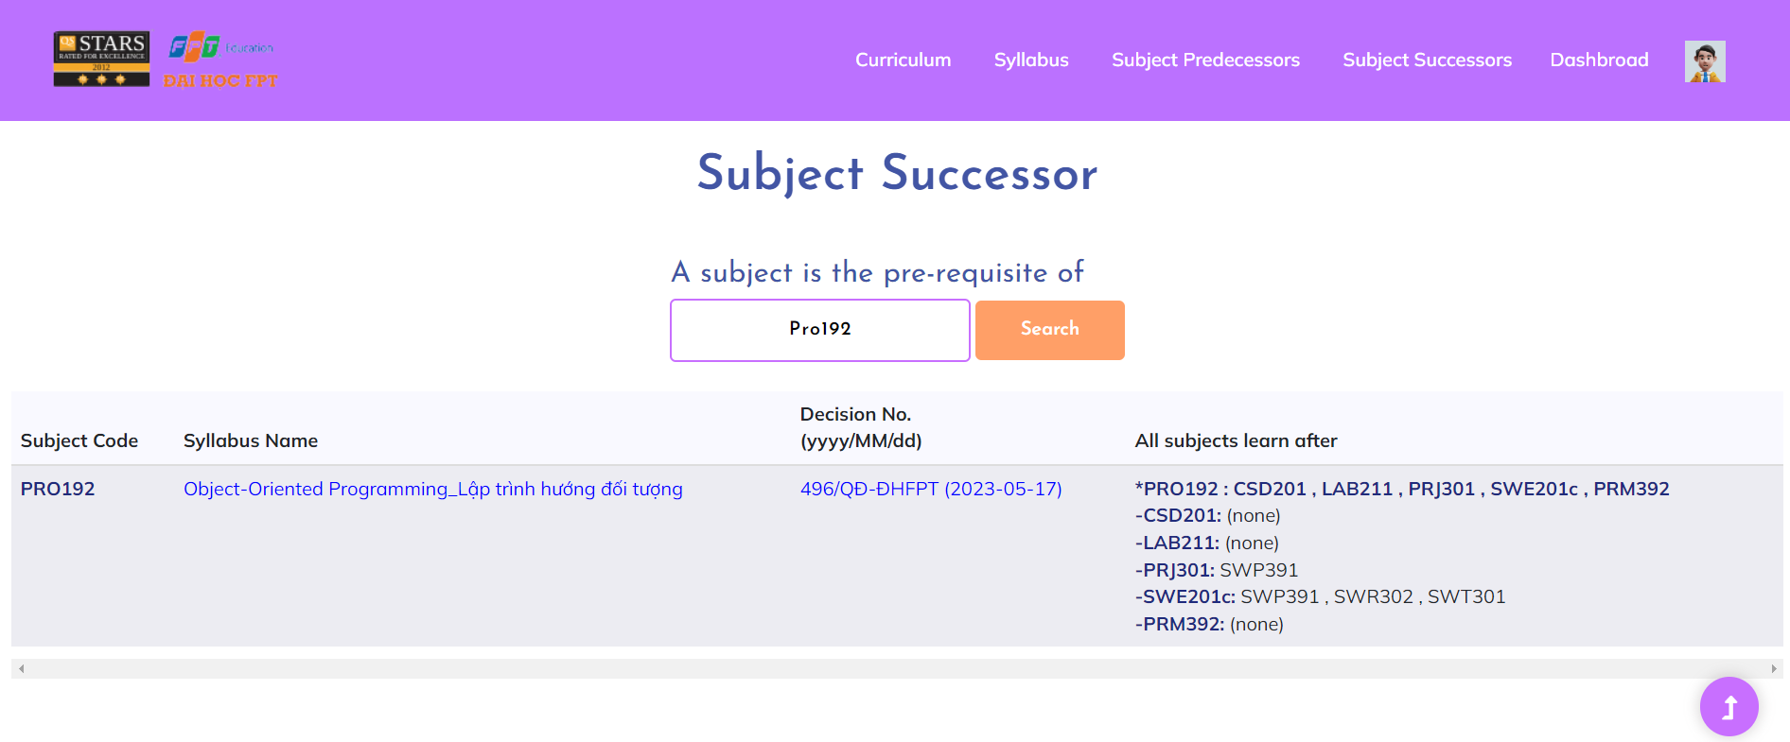

***User Guides***: After the user searches for a certain subject, it will display the curriculum and display the subjects that will be studied after completing this course.

**2.2.14. PO List**

***Actors***: All FLM user

***Screen/Function Description***: The "PO List" (Purchase Order List) feature refers to a comprehensive record of purchase orders related to the acquisition of learning materials, resources, or services within the system.

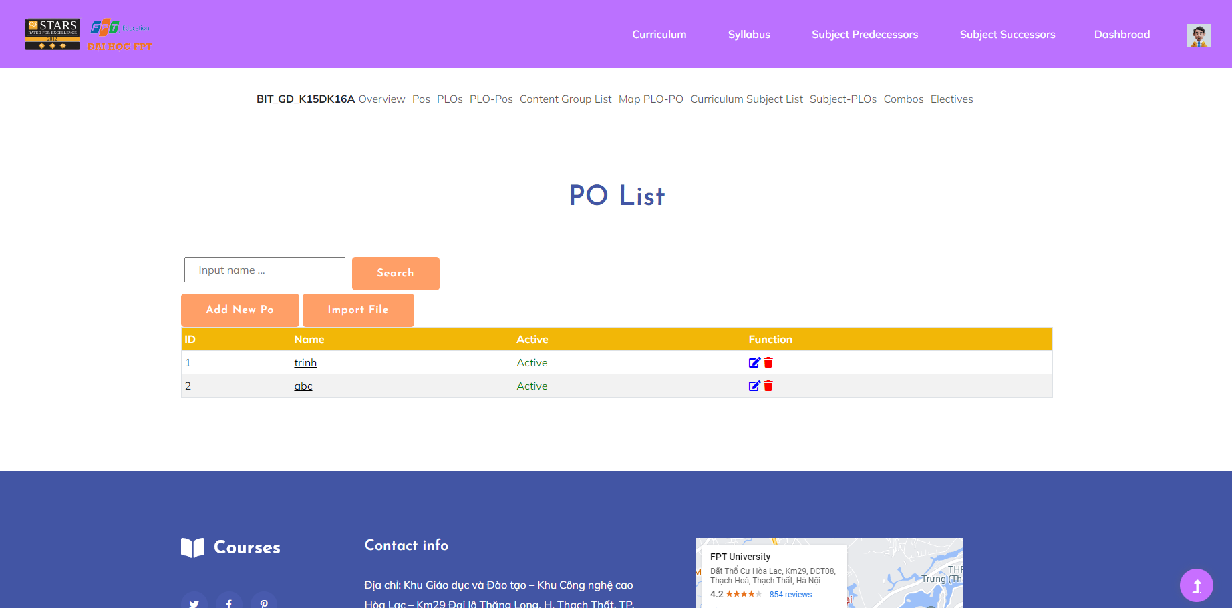

***User Guides***:

* User access FLM website then click on “Curriculum” on page header to access “Curriculum List” screen. After that, click on code of curriculum that you want to view detail then choose “POs” on the sub-header.
* On this screen, user can search PO

**2.2.15. PO Details**

***Actors***: All FLM user (view detail), staff (edit)

***Screen/Function Description***: The "PO Detail" feature provides a comprehensive view of the specifics of an individual purchase order. It offers detailed information about the procurement of learning materials, resources, or services within the system.

* PO Detail:

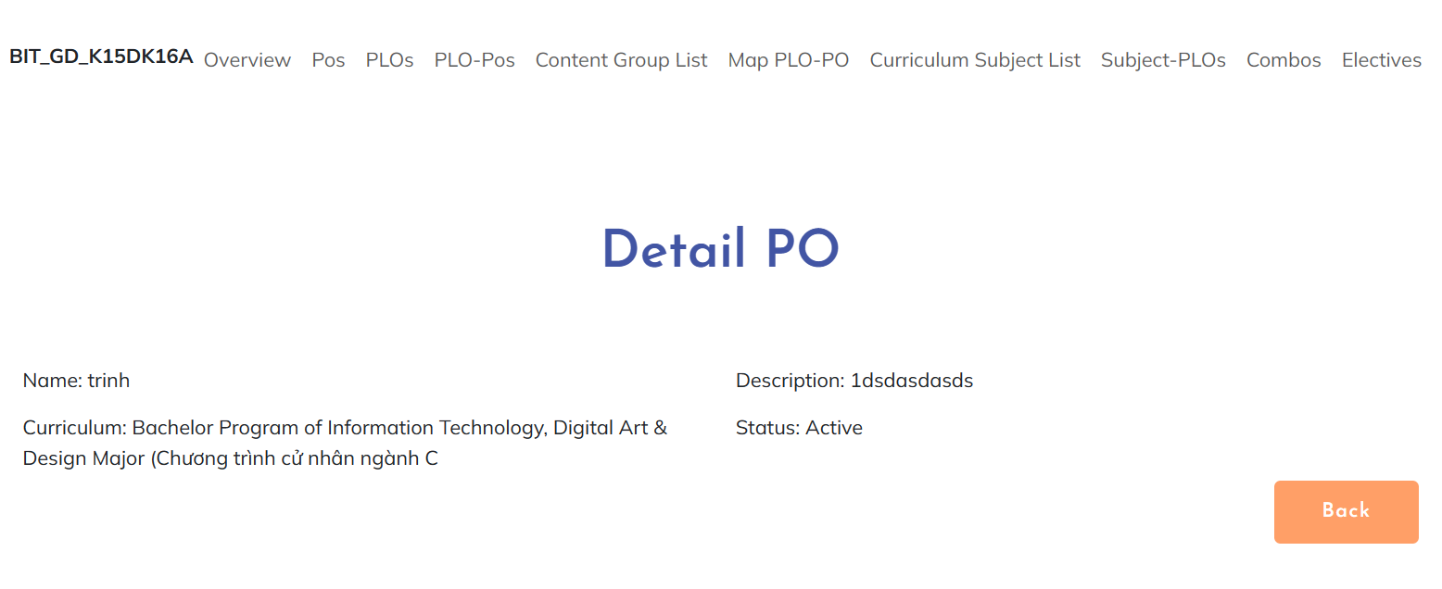

* PO Edit:

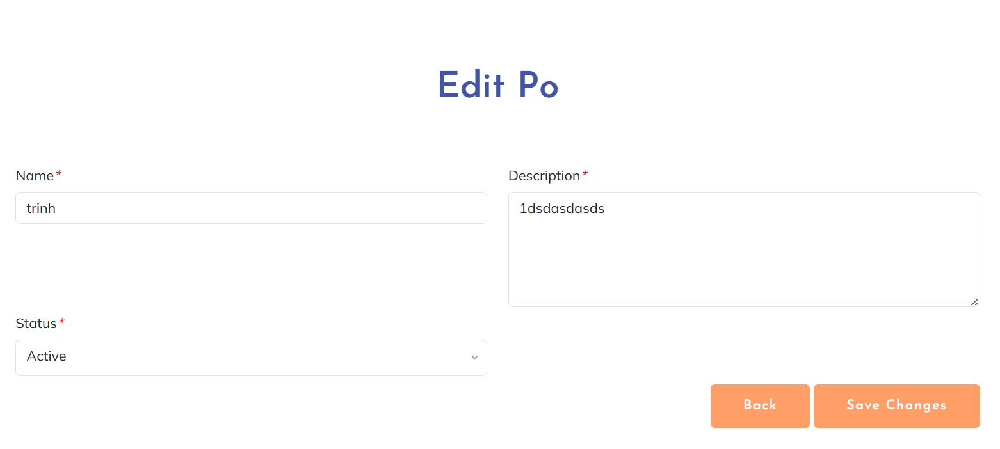

***User Guides***: - User access FLM website then click on “Curriculum” on page header to access “Curriculum List” screen. After that, click on code of curriculum that you want to view detail then choose “POs” on the sub-header. On this screen:

* PO detail: User click on name of group they want to view to see the detail
* PO edit: User click on “Edit” symbol button to edit content group, fill in blank with new information then click on “Save changes” button to update successfully

**2.2.16. PO Import**

***Actors***: Staff

***Screen/Function Description***: The "PO Import" enables administrators or finance personnel to upload and import purchase orders into the system in bulk. It streamlines the process of managing procurement activities by allowing users to import multiple purchase orders simultaneously using a standardised file format.

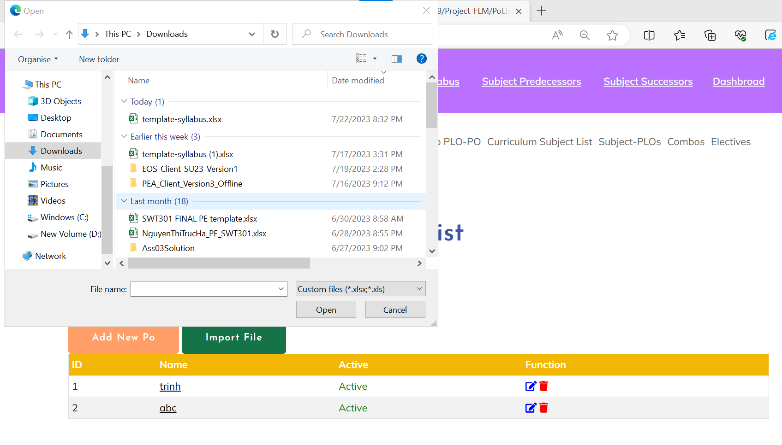

***User Guides***:

* User access FLM website then click on “Curriculum” on page header to access “Curriculum List” screen. After that, click on code of curriculum that you want to view detail then choose “POs” on the sub-header.
* On this screen: Click on “Import PO” button to upload file of PO to import new PO in the list

**2.2.17. PLO List**

***Actors***: All FLM user

***Screen/Function Description***: "PLO List" is a set of results of a curriculum that learners can get after finishing a curriculum. This function allows users to know clearly what they get after completing a curriculum

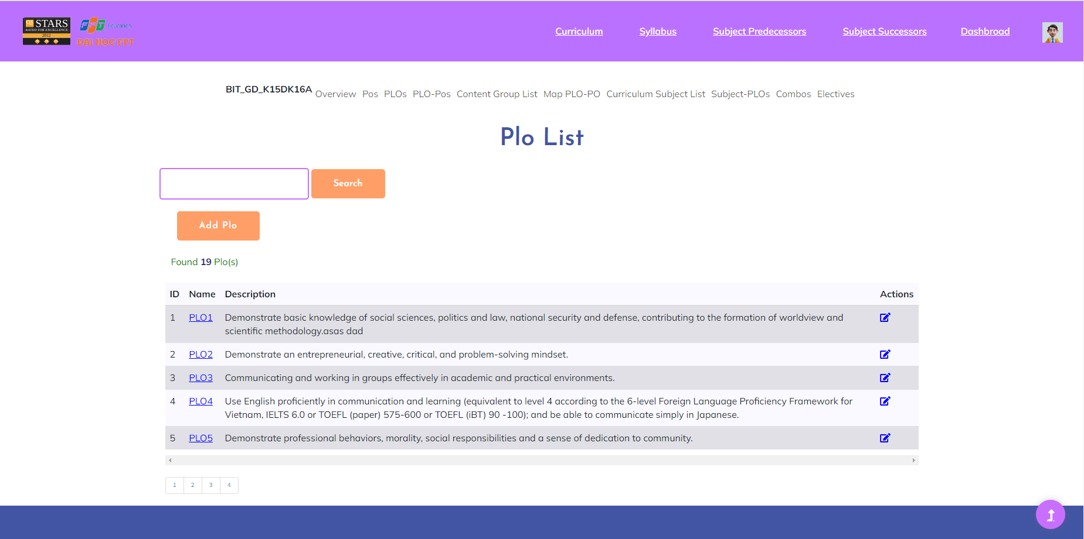

***User Guides***:

To access a plo list, the user must directly access a certain curriculum and will display a nav toolbar with the keyword PLOs, then click on it, the user will receive the PLO result corresponding to the curriculum he selected.



**2.2.18. PLO Detail**

***Actors***:All FLM user

***Screen/Function Description***: The PLO Detail function provides the user with a detailed way of the Plos that the user wants to learn.

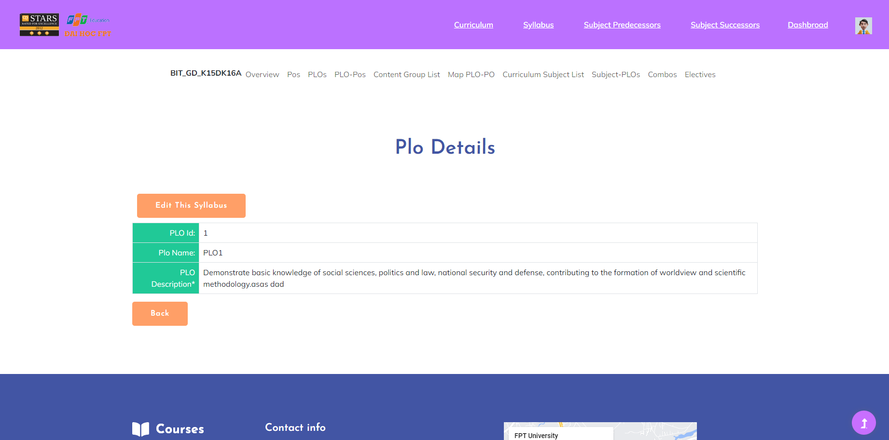

***User Guides***:After accessing the PLO list, while displaying the plo list, there is a link under the name of each PLO, as long as the user clicks on a link, he can access the PLO details that the user wants.

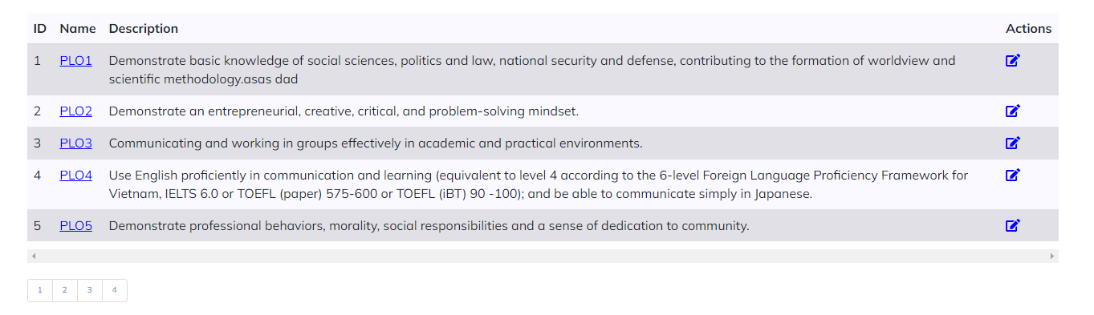

**2.2.19. PLO-PO Mapping**

***Actors***:All FLM user

***Screen/Function Description***:The PLO PO mapping function helps to identify the relationship between specific learning objectives (PLOs) and general learning objectives (POs). This alignment clarifies that program-specific learning objectives (PLOs) support the achievement of that program's overall learning objectives (POs).

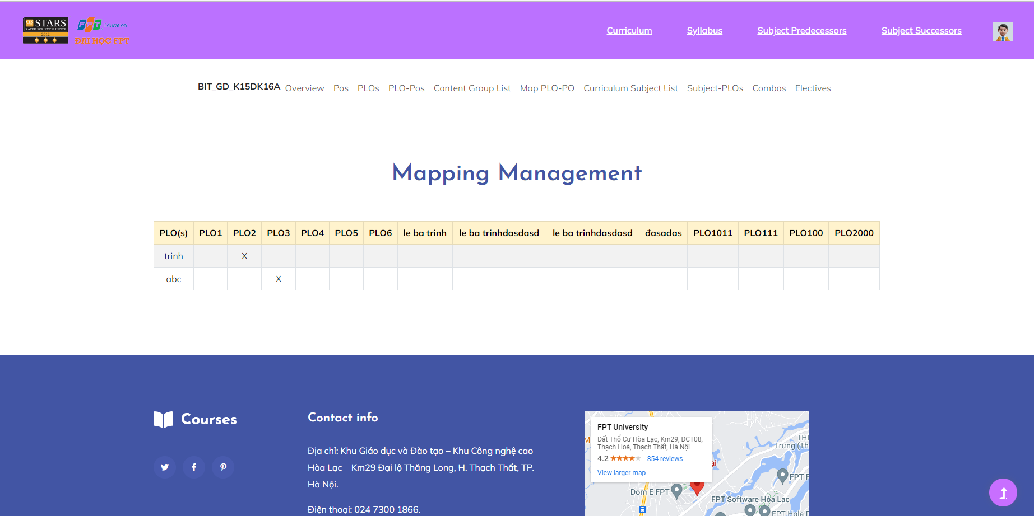

***User Guides***:

To access a PLO PO Mapping, the user must directly access a certain course and will display the navigation toolbar with the keyword PLOs, then click on Map PLO PO, the user will see the map lists with that x.

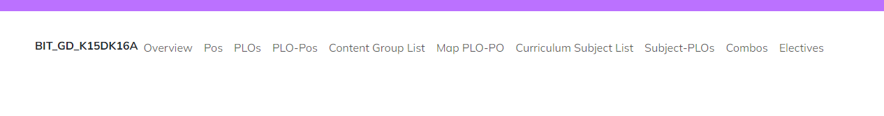

**2.2.20. Combo List**

***Actors***: All FLM Users

***Screen/Function Description***: "Combo List" is a feature in the Learning Management System that organises the association of education into logical groups or categories. It enhances the organisation and accessibility of learning materials for both educators and learners, allowing them to easily locate and manage subjects.

* Screen for guest and normal role:

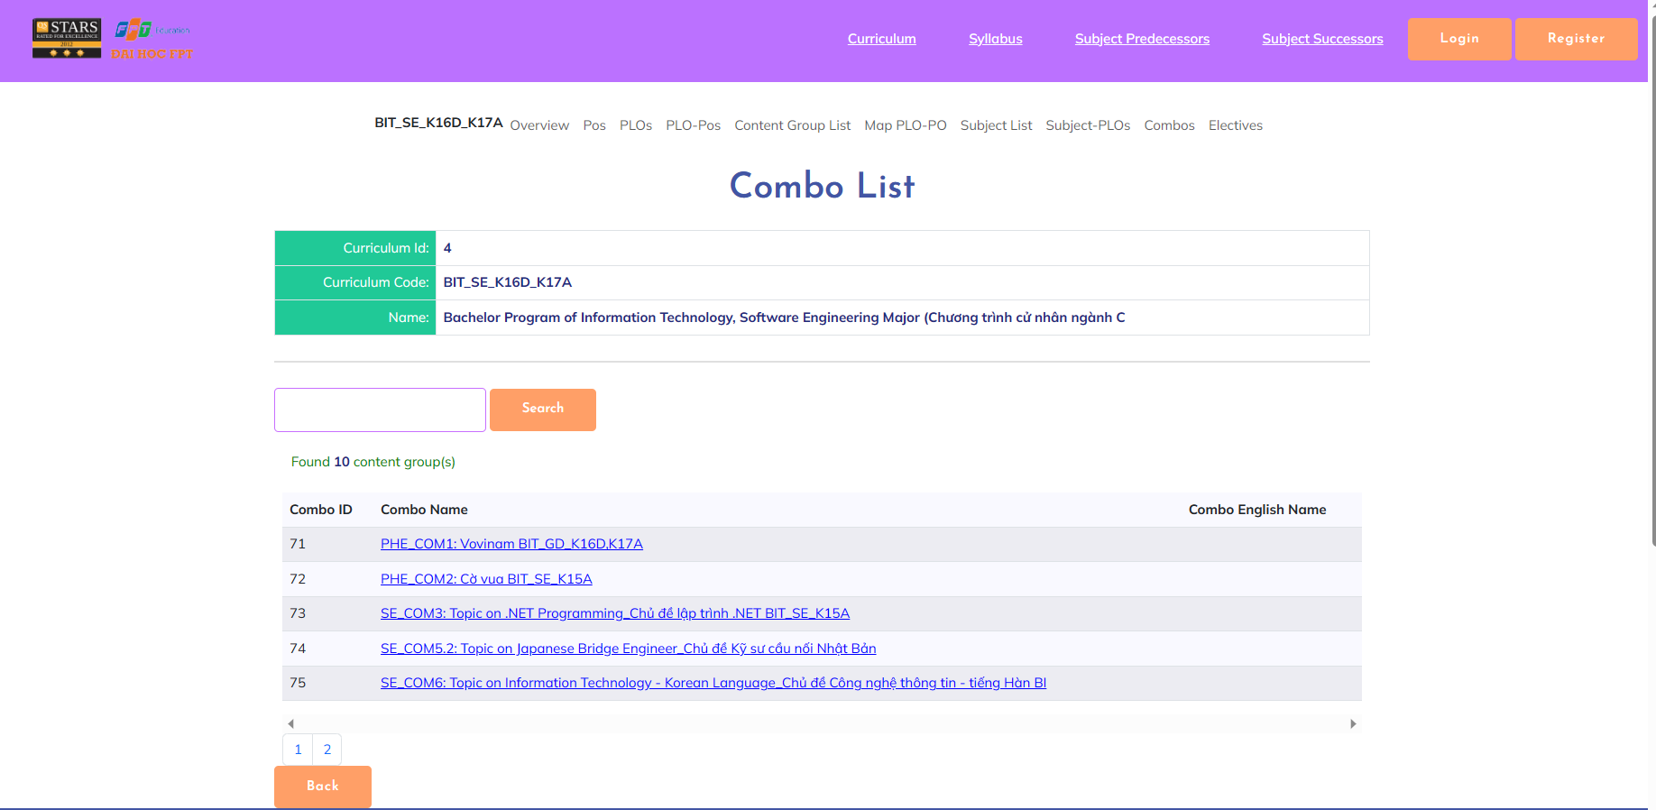

* Screen when login as staff:

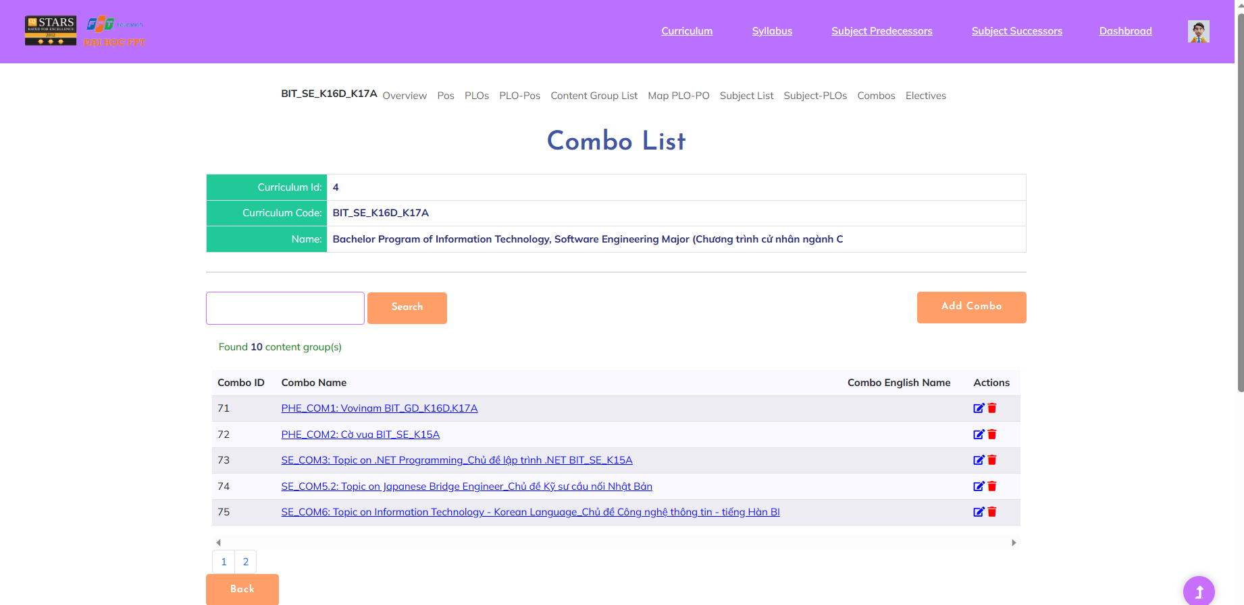

***User Guides***:User access FLM website then click on “Curriculum” on page header to access “Curriculum List” screen. After that, click on code of curriculum that you want to view detail then choose “Combo list” on the sub-header.

On this screen, user can view, search for combo. For some certain role, they can delete combo and have the path to add or edit combo for the curriculum from this screen.

**2.2.21. Combo Detail**

***Actors***: All FLM User (view detail), CRDD Staff (add, edit)

***Screen/Function Description***: The "Combo Detail" feature in a Learning Management System (LMS) provides a comprehensive view of a specific combo within the system. It offers educators and administrators detailed information about the content within the combo, enabling them to manage, customise, and monitor the learning materials effectively.

* Screen for guest and normal role:

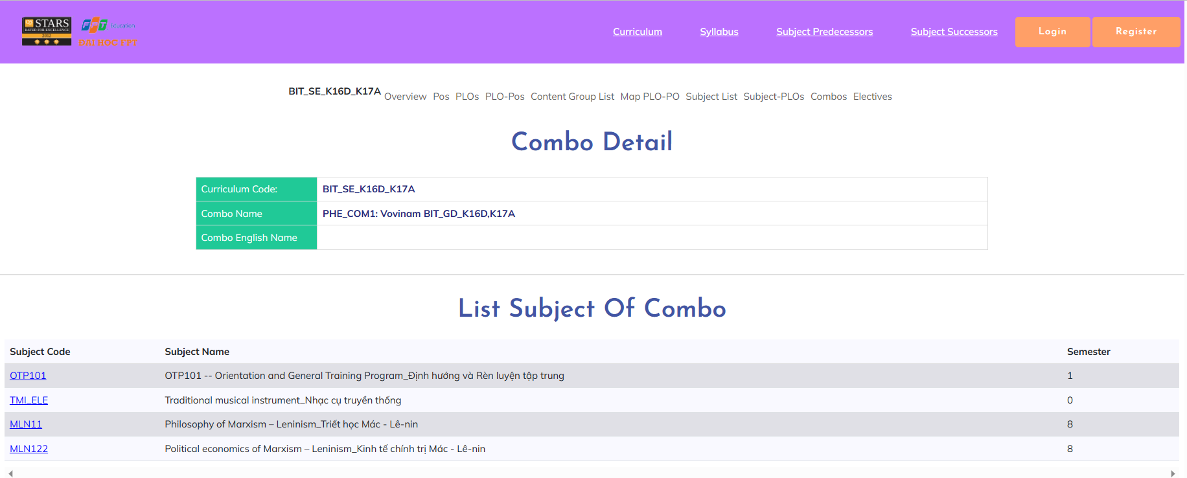

* Screen when login as staff:
* Add new combo:

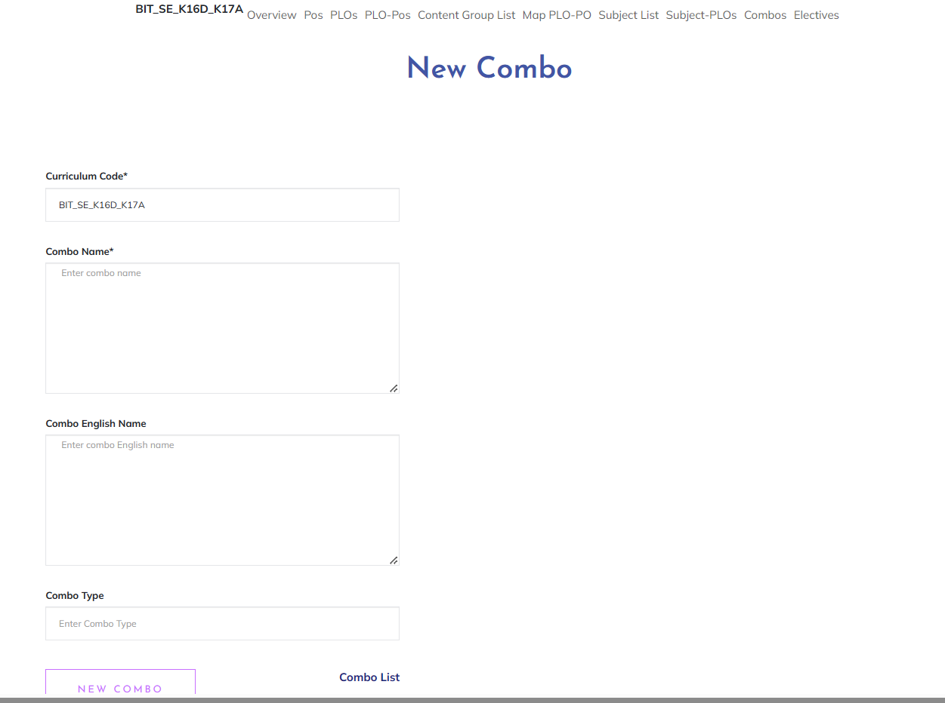

* Combo Detail:
* 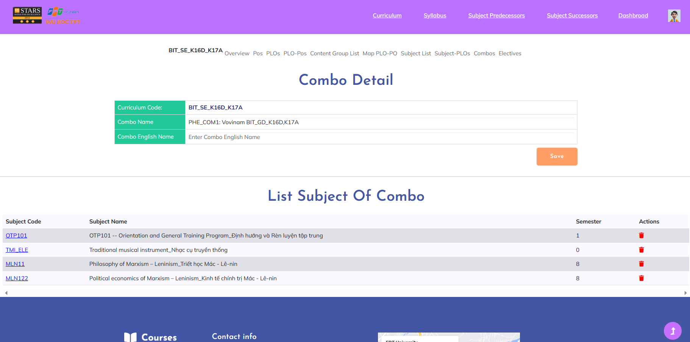

***User Guides***: User access FLM website then click on “Curriculum” on page header to access “Curriculum List” screen. After that, click on code of curriculum that you want to view detail then choose “Combo list” on the sub-header. From this screen:

Add combo: User click on “Add combo” button. Fill on the blank then click on “New Combo” button to create combo.

Combo detail: User click on name of combo they want to view to see the detail

Combo edit: User click on “Edit” symbol button to edit combo, fill in blank with new information then click on “Edit” button to update successfully

**2.2.22. Content Group List**

***Actors***: All FLM User

***Screen/Function Description***: A "Content Group List" is a feature within a Learning Management System that organises educational content into logical groups or categories. It enhances the organisation and accessibility of learning materials for both educators and learners, allowing them to easily locate and manage content.

* Screen for guest and normal role:

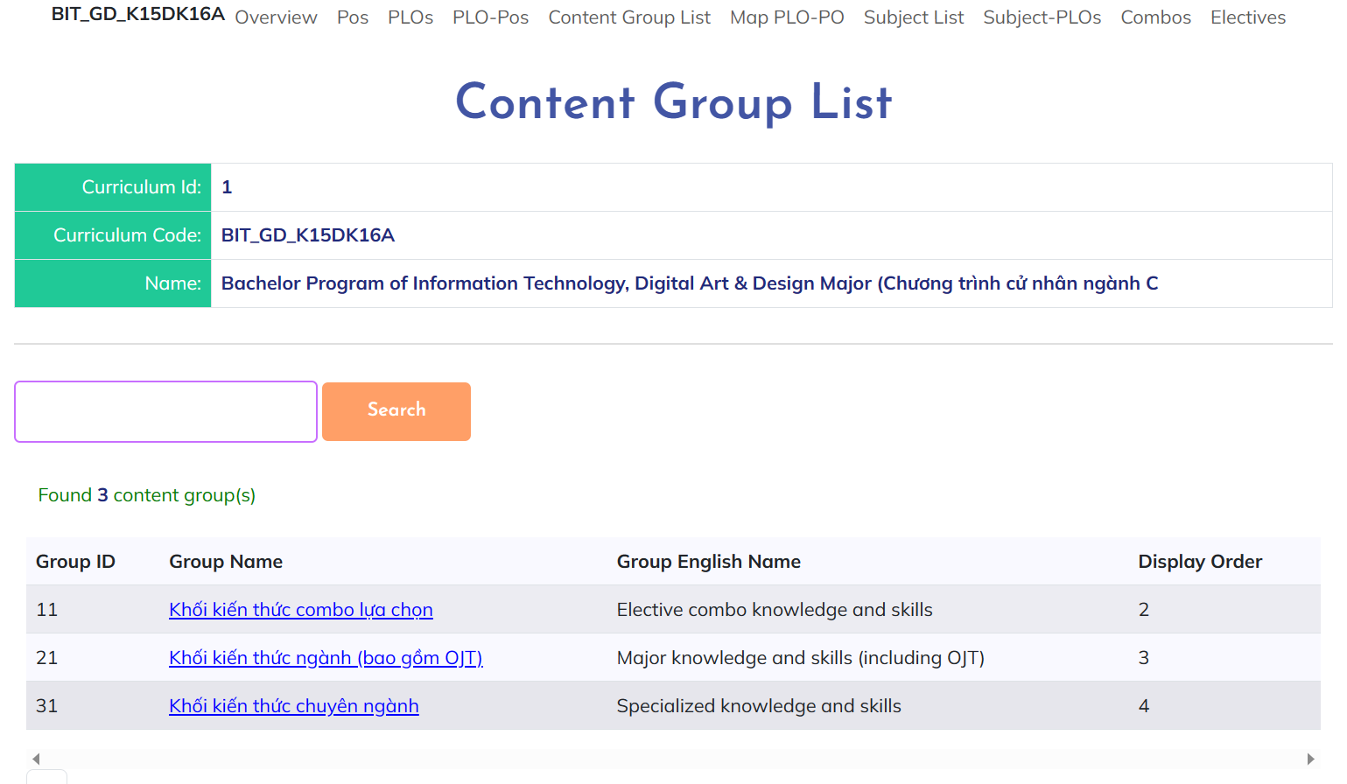

* Screen when login as staff:

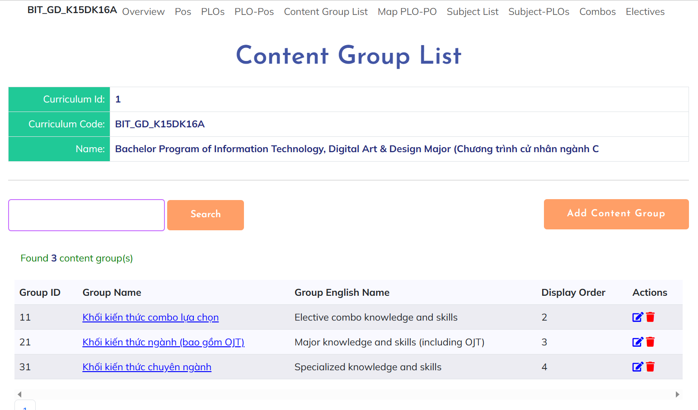

***User Guides***:

* User access FLM website then click on “Curriculum” on page header to access “Curriculum List” screen. After that, click on code of curriculum that you want to view detail then choose “Content group list” on the sub-header.
* On this screen, user can view, search for content group. For some certain role, they can delete content group and have the path to add or edit content group for the curriculum from this screen.

**2.2.23. Content Group Detail**

***Actors***: All FLM User (view detail), CRDD Staff (add, edit)

***Screen/Function Description***: The "Content Group Detail" feature in a Learning Management System (LMS) provides a comprehensive view of a specific content group within the system. It offers educators and administrators detailed information about the content within the group, enabling them to manage, customise, and monitor the learning materials effectively.

* Add new content group:

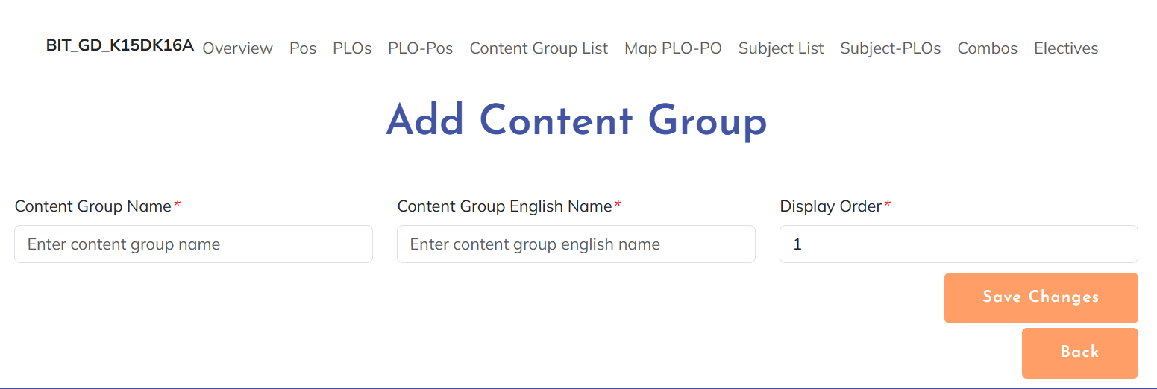

* Edit content group:

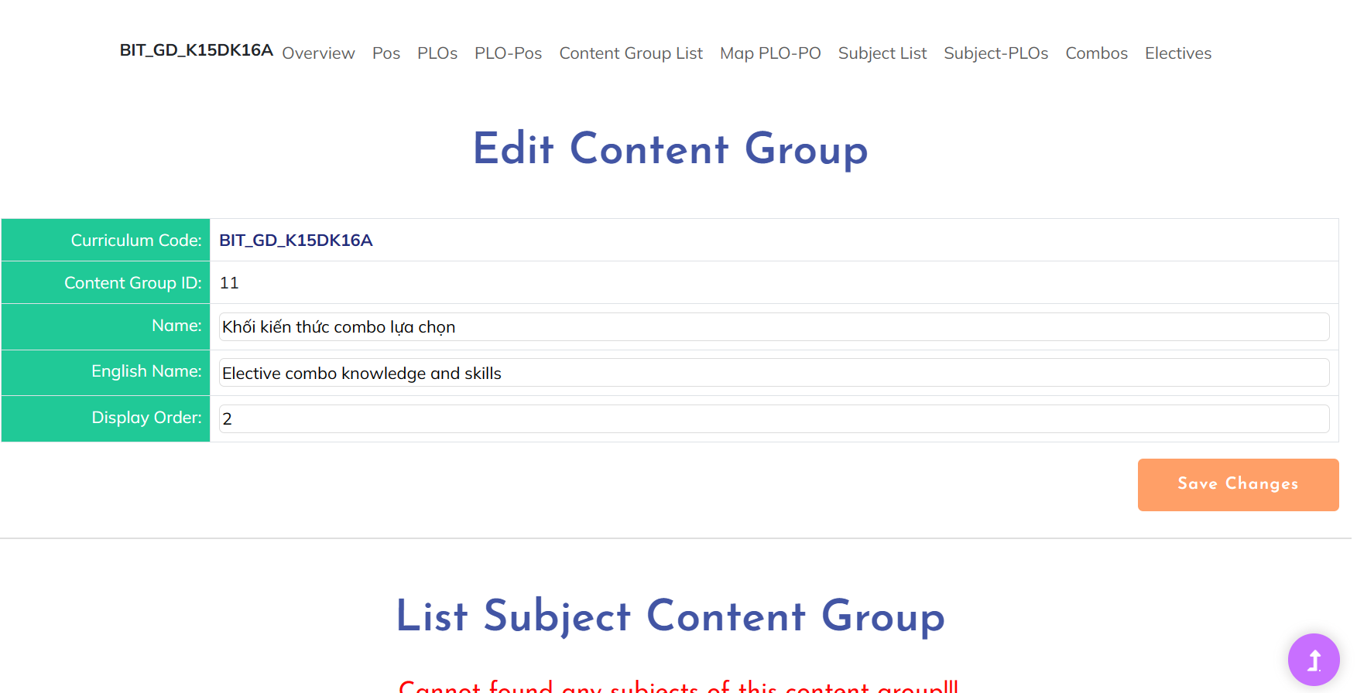

* View content group detail:

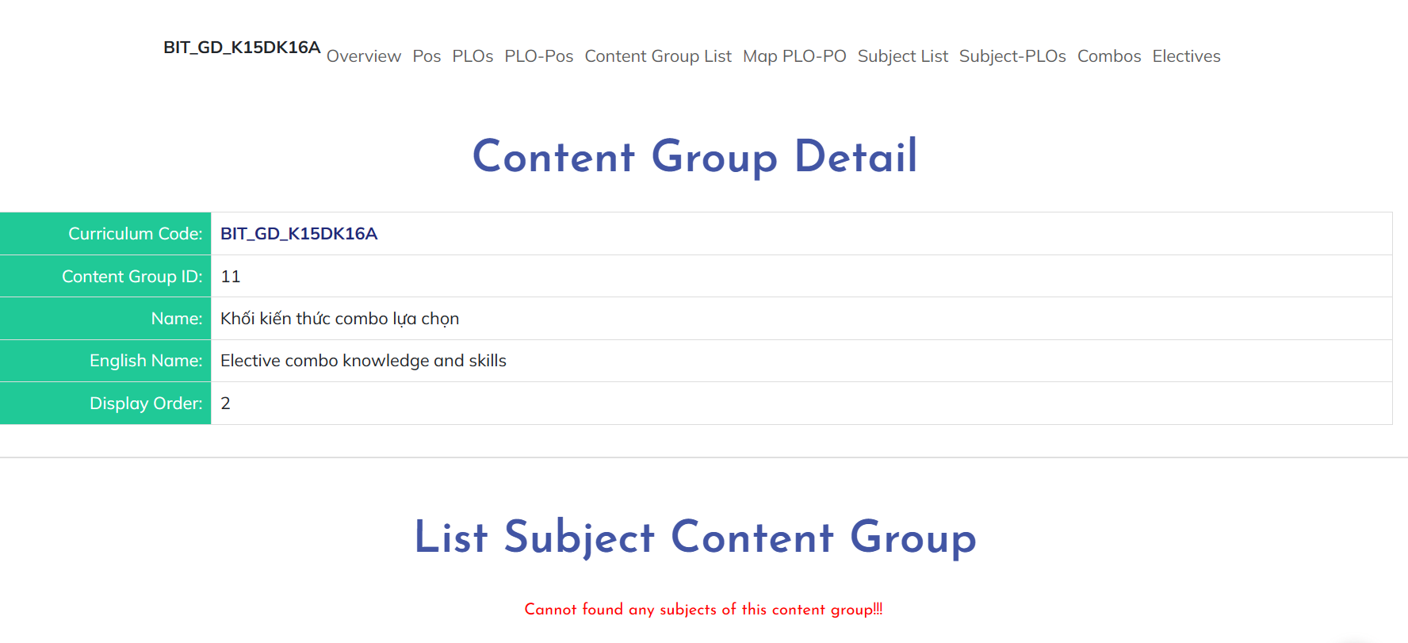

***User Guides***:

* User access FLM website then click on “Curriculum” on page header to access “Curriculum List” screen. After that, click on code of curriculum that you want to view detail then choose “Content group list” on the sub-header. From this screen:
* Add content group: User click on “Add content group” button. Fill on the blank then click on “Save changes” button to create content group.
* Content group detail: User click on name of group they want to view to see the detail
* Content group edit: User click on “Edit” symbol button to edit content group, fill in blank with new information then click on “Save changes” button to update successfully

**2.2.24. Elective List**

***Actors***: All FLM User

***Screen/Function Description***: The "Elective List" feature provides users with a comprehensive catalogue of elective courses or subjects available for them to choose from. Electives are additional courses that students can select based on their interests, career goals, or academic preferences, offering them a degree of flexibility in shaping their educational journey.

* Screen for guest and normal role:

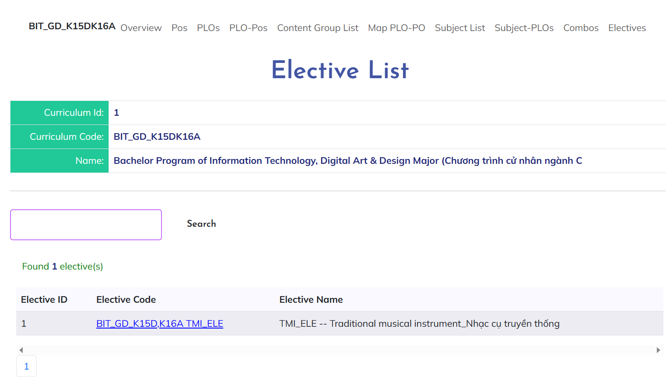

* Screen when login as staff:

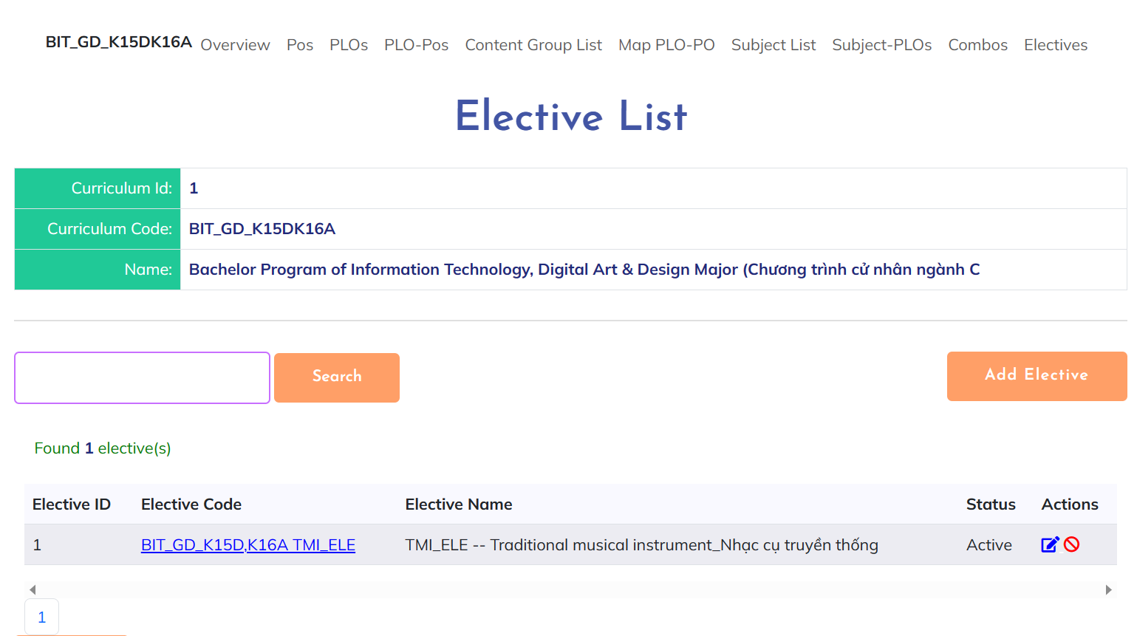

***User Guides***:

* User access FLM website then click on “Curriculum” on page header to access “Curriculum List” screen. After that, click on code of curriculum that you want to view detail then choose “Electives” on the sub-header.
* On this screen, user can view, search for elective. For some certain role, they can activate/deactivate elective and have the path to add or edit elective for the curriculum from this screen.

**2.2.25. Elective Detail**

***Actors***: All FLM User (view detail), CRDD Staff (add, edit)

***Screen/Function Description***: The "Elective Detail" feature provides a comprehensive view of a specific elective course within the system. It offers users detailed information about the elective course, enabling them to make informed decisions about course selection and enrollment.

* Add new elective:

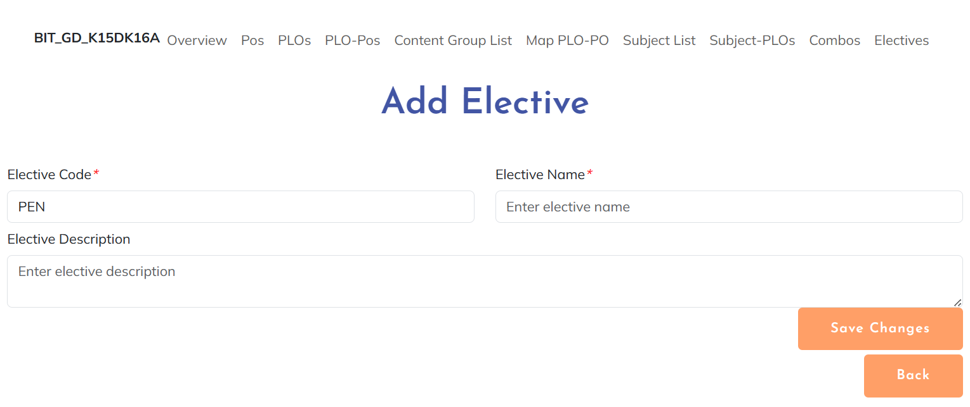

* Edit elective:

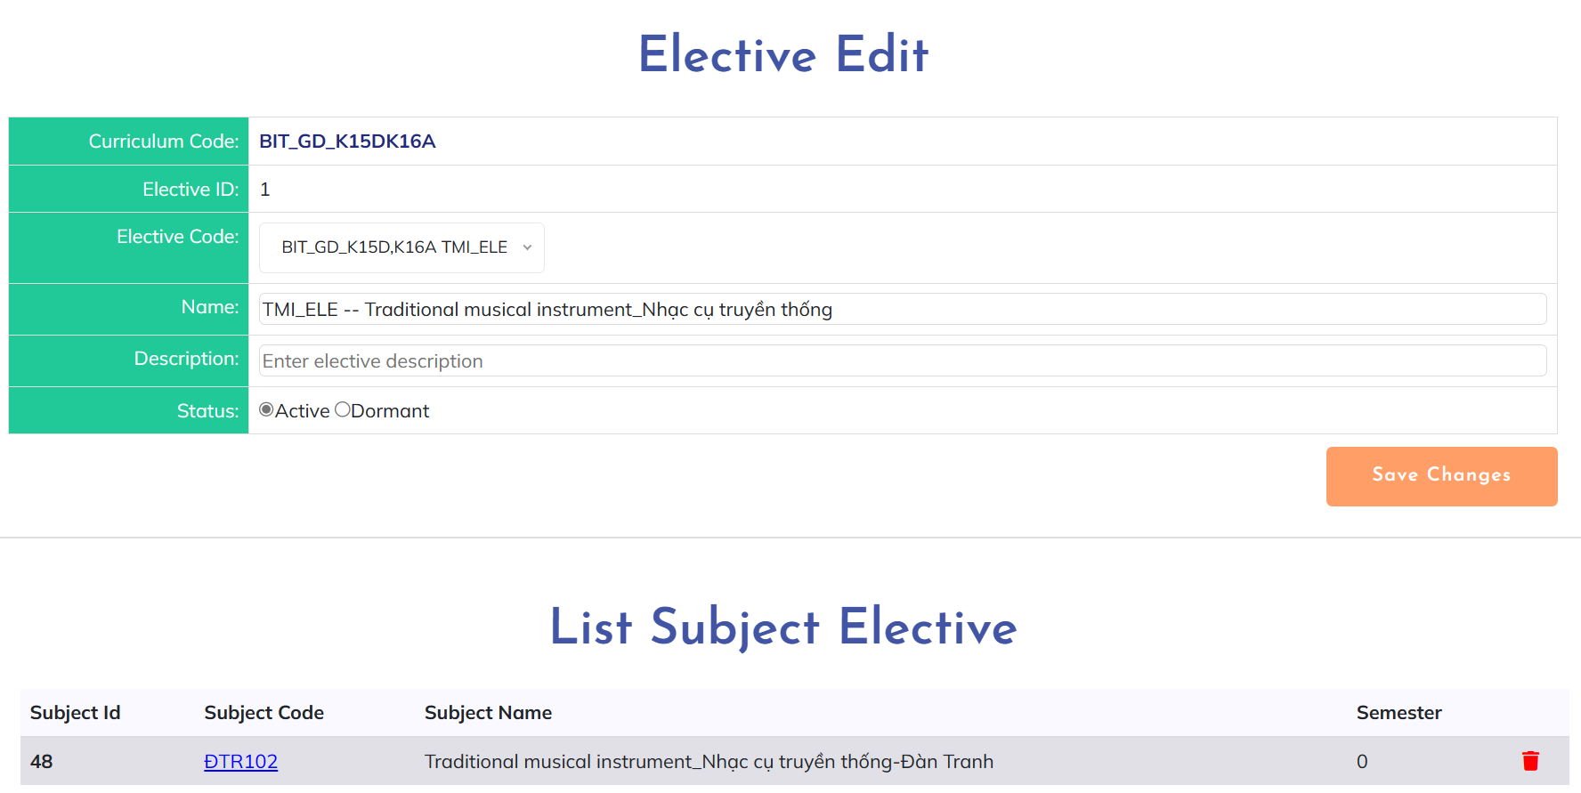

* View elective detail:

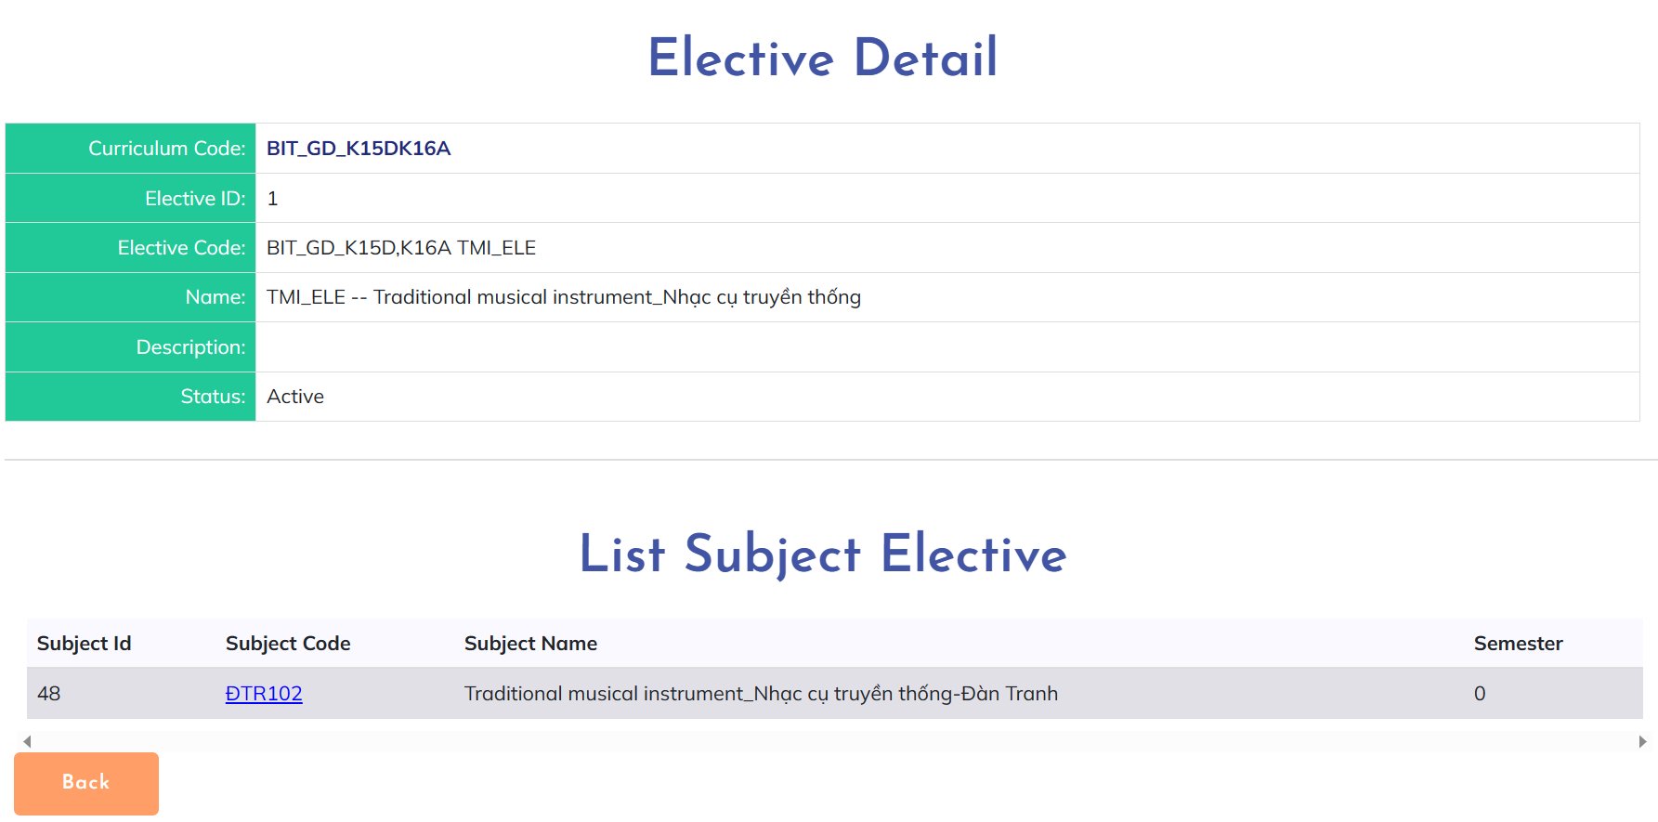

***User Guides***:

* User access FLM website then click on “Curriculum” on page header to access “Curriculum List” screen. After that, click on code of curriculum that you want to view detail then choose “Electives” on the sub-header. From this screen:
* Add elective: User click on “Add elective” button. Fill on the blank then click on “Save changes” button to create elective.
* Elective detail: User click on code of elective they want to view to see the detail
* Elective edit: User click on “Edit” symbol button to edit elective, fill in blank with new information then click on “Save changes” button to update successfully

**2.2.26. Decision List**

***Actors***: CRDD Staff

***Screen/Function Description***: The "Decision List" shows a list of decisions

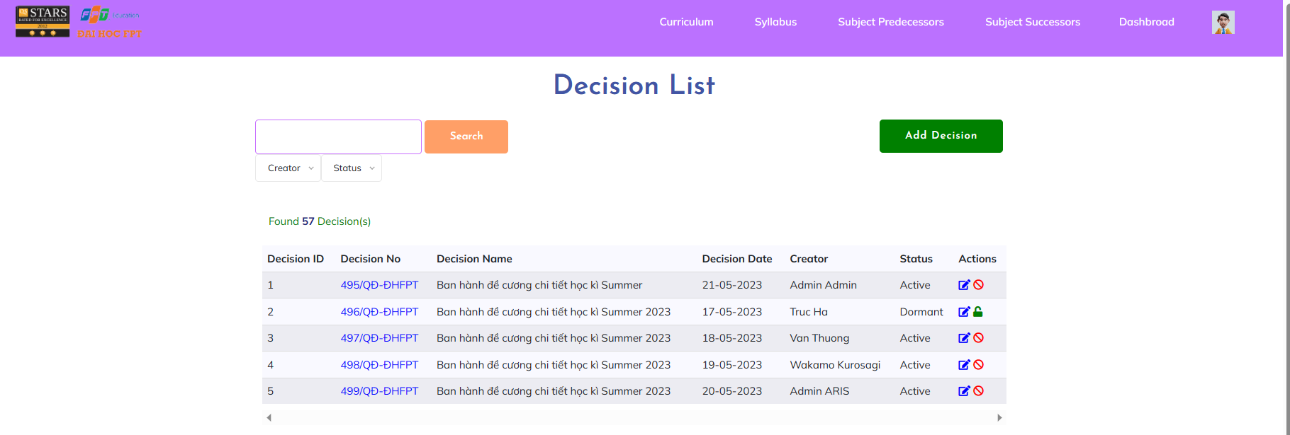

***User Guides***:Only staff can access this page to manage the decision to add, edit, delete

**2.2.27. New Decision**

***Actors***: CRDD Staff

***Screen/Function Description***: The "New decision" adds a new decision to the system

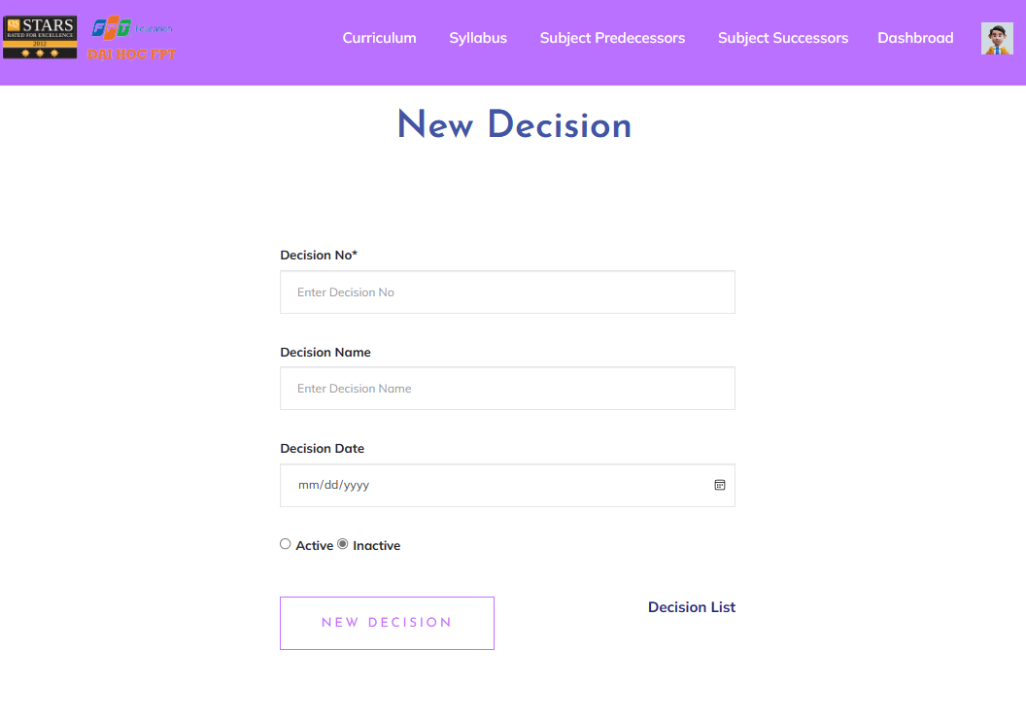

***User Guides***: After filling in the data in the new decision, a new decision will be created and displayed in the decision List

**2.2.28. Decision Detail**

***Actors***: CRDD Staff

***Screen/Function Description***: The "Decision Details" shows the basic information of a modifiable Decision and the corresponding curriculum and syllabus.

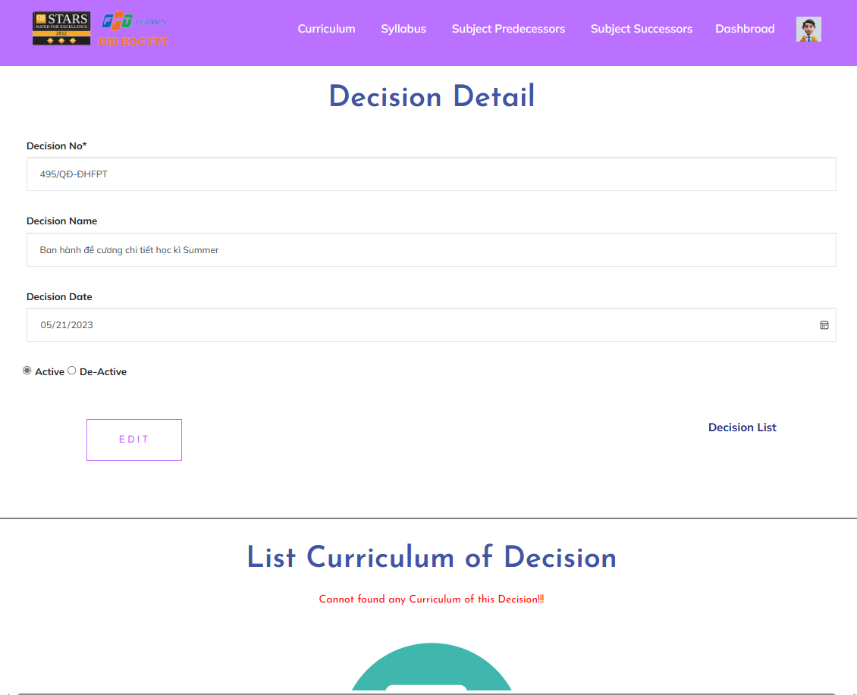

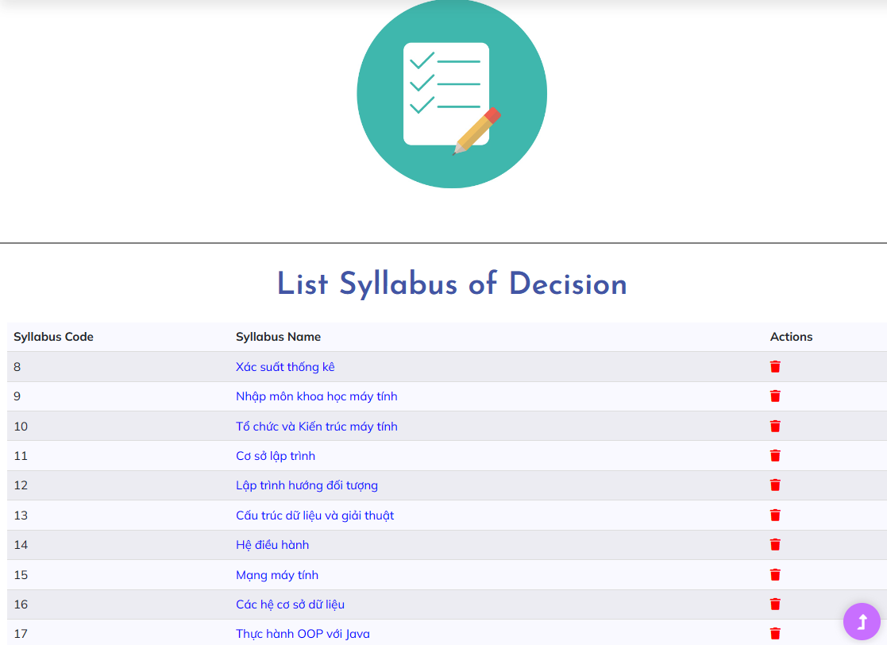

***User Guides***:after entering the decison detail one can view the decision information and can change them but not decision no, and can see the respective curriculum and the corresponding syllabus and can delete it from this decision

## 2.3. Syllabus Workflow

**2.3.1. Syllabus List**

***Actors***: All FLM Users excluding guest

***Screen/Function Description***: The "Syllabus List" feature provides a centralised and organised catalogue of syllabi for all the courses offered within the educational institution or learning platform. It serves as a valuable resource for students, educators, and administrators, offering detailed information about the content, objectives, assessments, and other essential aspects of each course.

* Screen as normal role:

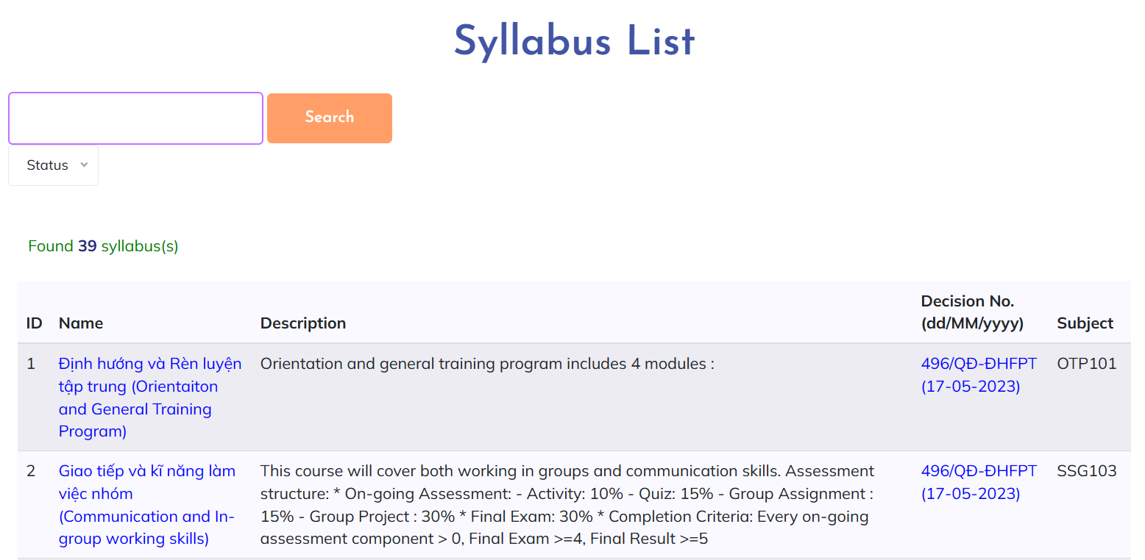

* Screen when login as staff:

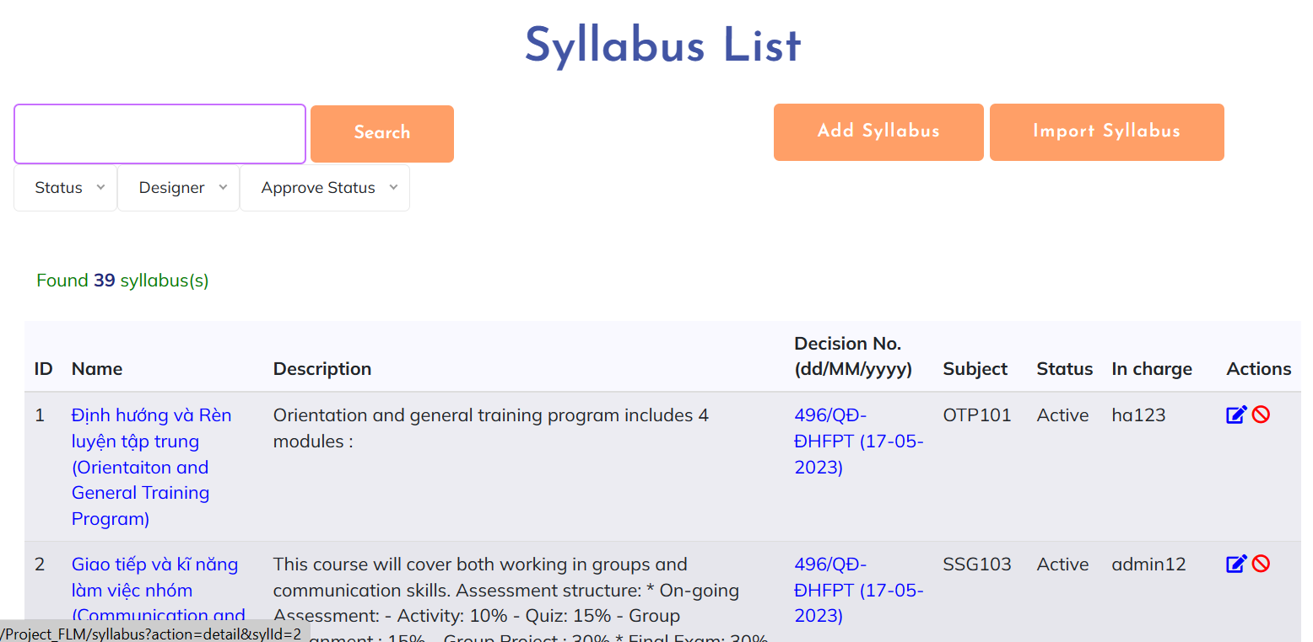

***User Guides***:

* User access FLM website then click on “Syllabus” on page header
* On this screen, user can view, search, filter for syllabus. For some certain role, they can activate, deactivate syllabus and have the path to add or edit or import syllabus from this screen.

**2.3.2. New Syllabus**

***Actors***: Syllabus Designer

***Screen/Function Description***: The "Syllabus Add" feature enables educators or course administrators to create and add new syllabi for courses directly within the system. This feature streamlines the process of setting up new courses or updating existing ones by providing a user-friendly interface to input and organise course information.

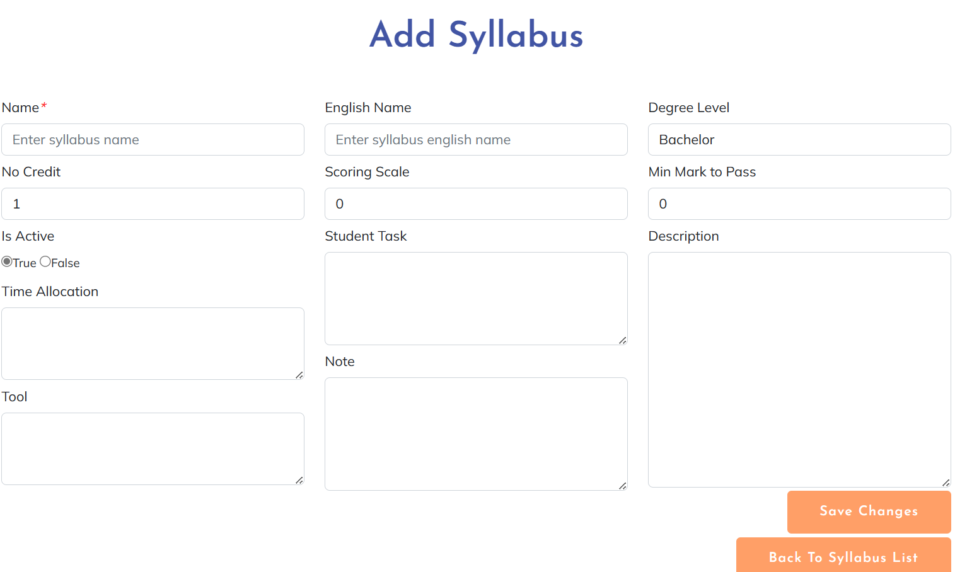

***User Guides***: Syllabus Designer click on “Add syllabus” button. Fill on the blank then click on “Save changes” button to create syllabus.

**2.3.3. Syllabus Overview**

***Actors***: All FLM Users

***Screen/Function Description***: The "Syllabus Overview" feature provides a concise and accessible summary of a course's syllabus. It offers students and educators a quick glance at the essential components and key information of the course without having to access the detailed syllabus document.

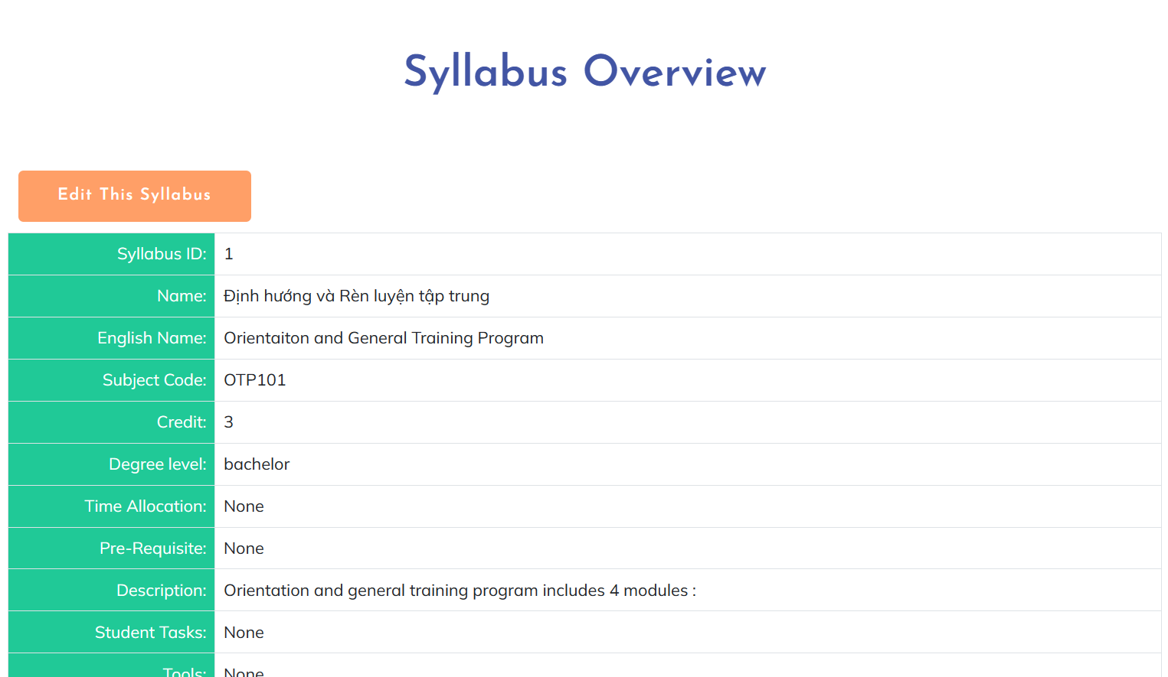

***User Guides***: User click on name of syllabus they want to view to see the detail

**2.3.4. Syllabus Import**

***Actors***: Syllabus Designer

***Screen/Function Description***: The "Syllabus Import" feature enables educators or administrators to import course syllabi in various formats directly into the system. This feature streamlines the process of creating new courses or updating existing ones by automatically populating course information from external sources.

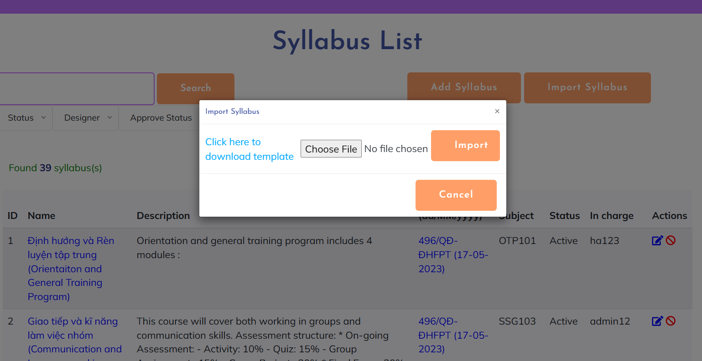

***User Guides***:

* Syllabus Designer click on “Import Syllabus” button to open import modal
* Click on “Click here to download template” download the template and follow the instructions to fill in information for syllabus he/she wants to import
* After finishing filling information for syllabus, click on “Choose file”, choose previous file then click on “Import” button to import syllabus

**2.3.5. Syllabus Edit**

***Actors***: Syllabus Designer

***Screen/Function Description***: The "Syllabus Edit" feature allows educators or course administrators to modify and update the content and details of a course syllabus. It empowers them to keep the course syllabus accurate, relevant, and up-to-date with any changes in the curriculum, course objectives, assessments, or other aspects of the course.

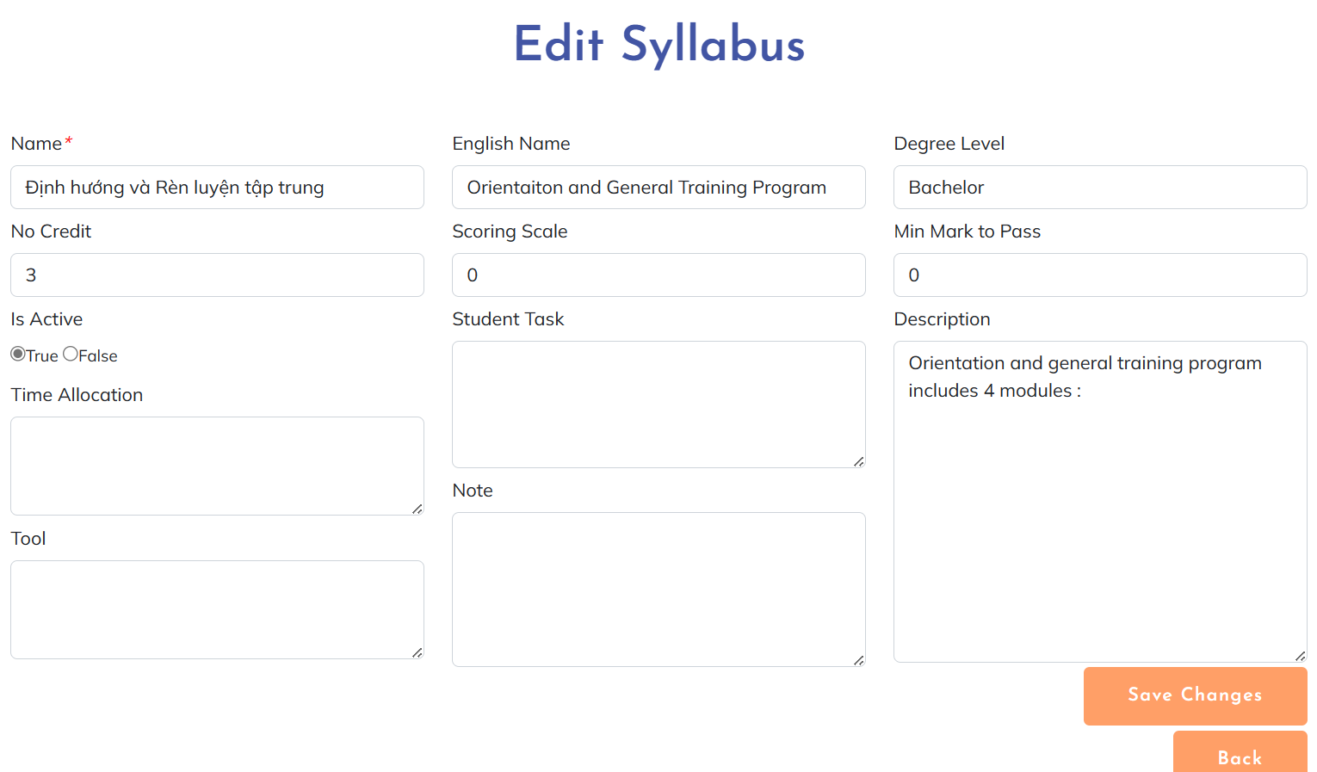

***User Guides***: User click on “Edit” symbol button to edit syllabus, fill in blank with new information then click on “Save changes” button to update successfully

**2.3.6. CLO List**

***Actors***: All FLM user

***Screen/Function Description***: The CLO List function is responsible for providing users with a comprehensive list of CLO specifically tailored for FLM. The function should display the PO in a structured and organised manner, allowing users to easily search, filter, and access the relevant outcomes.

* Screen as guest or login with user role:

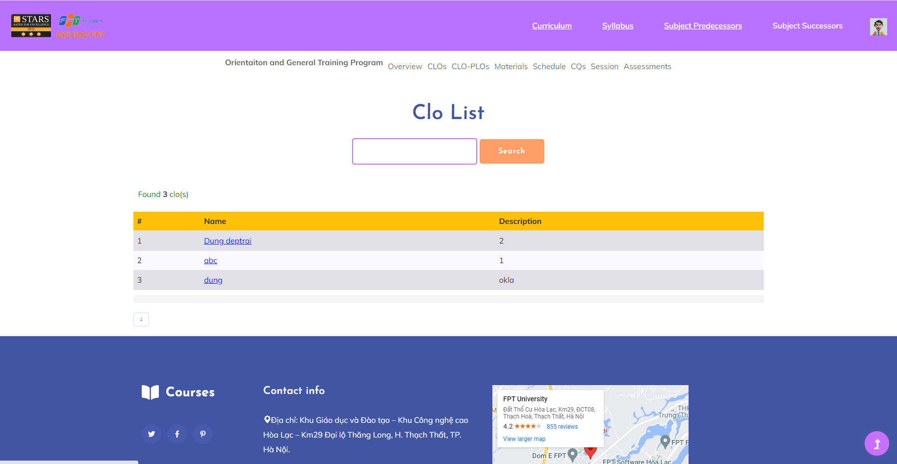

* Screen after logging in as admin:

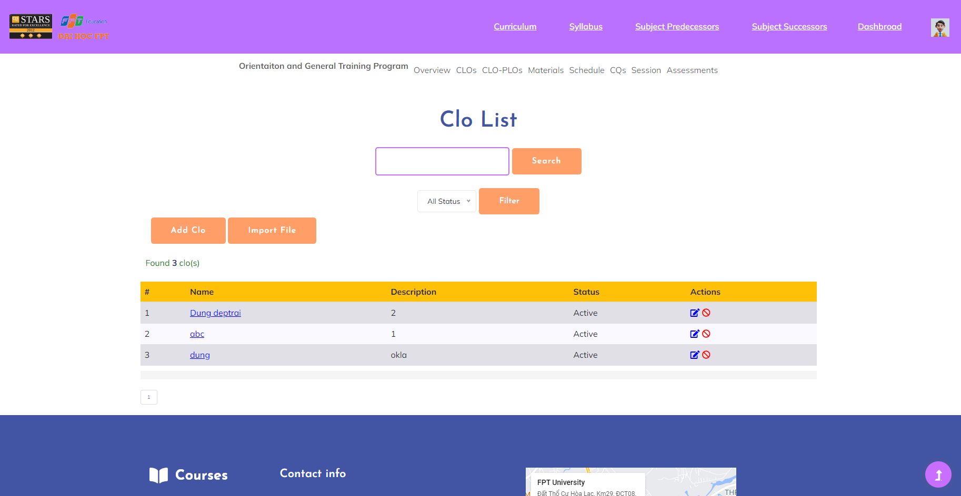

***User Guides***:

* Users access the FLM website then click on “Syllabus” on the page header. The user then clicks on the name of Syllabus, then clicks the "CLOs" button.
* On this screen, users can view, search, and filter. For some certain role, they can activate, deactivate syllabus and have the path to add or edit or import CLO from this screen.

**2.3.7. CLO Detail**

***Actors***: All FLM user

***Screen/Function Description***: The CLO Details function provides users with in-depth information and comprehensive details about a specific CLO. When users click on Name from the list of CLO in the Syllabus, an "CLO Details" view is displayed, providing insights for all users.

This feature contains CLO Details for all users and Add Clo, Edit CLO for admin:

* CLO Details

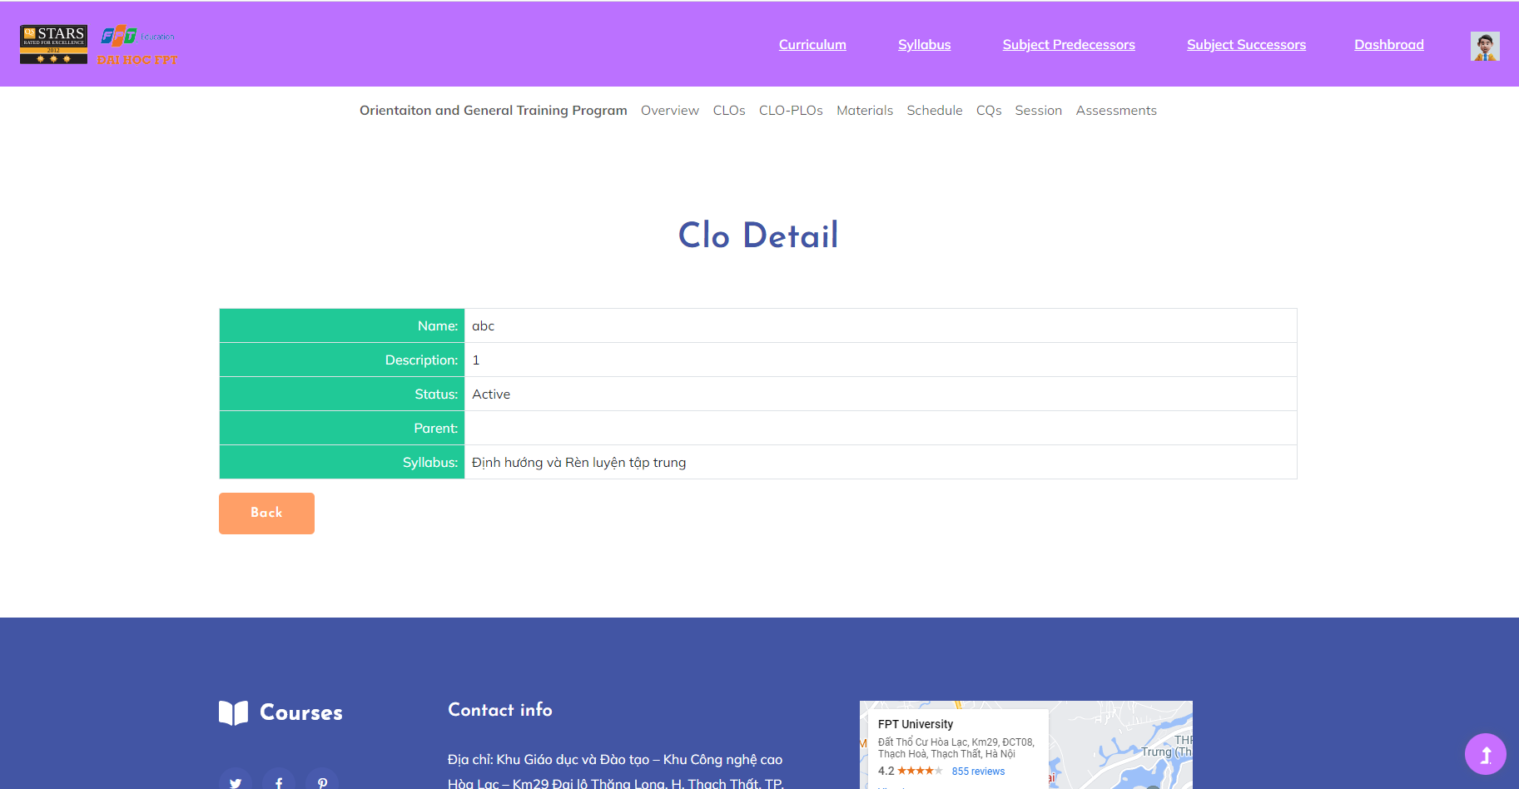

* Add Clo

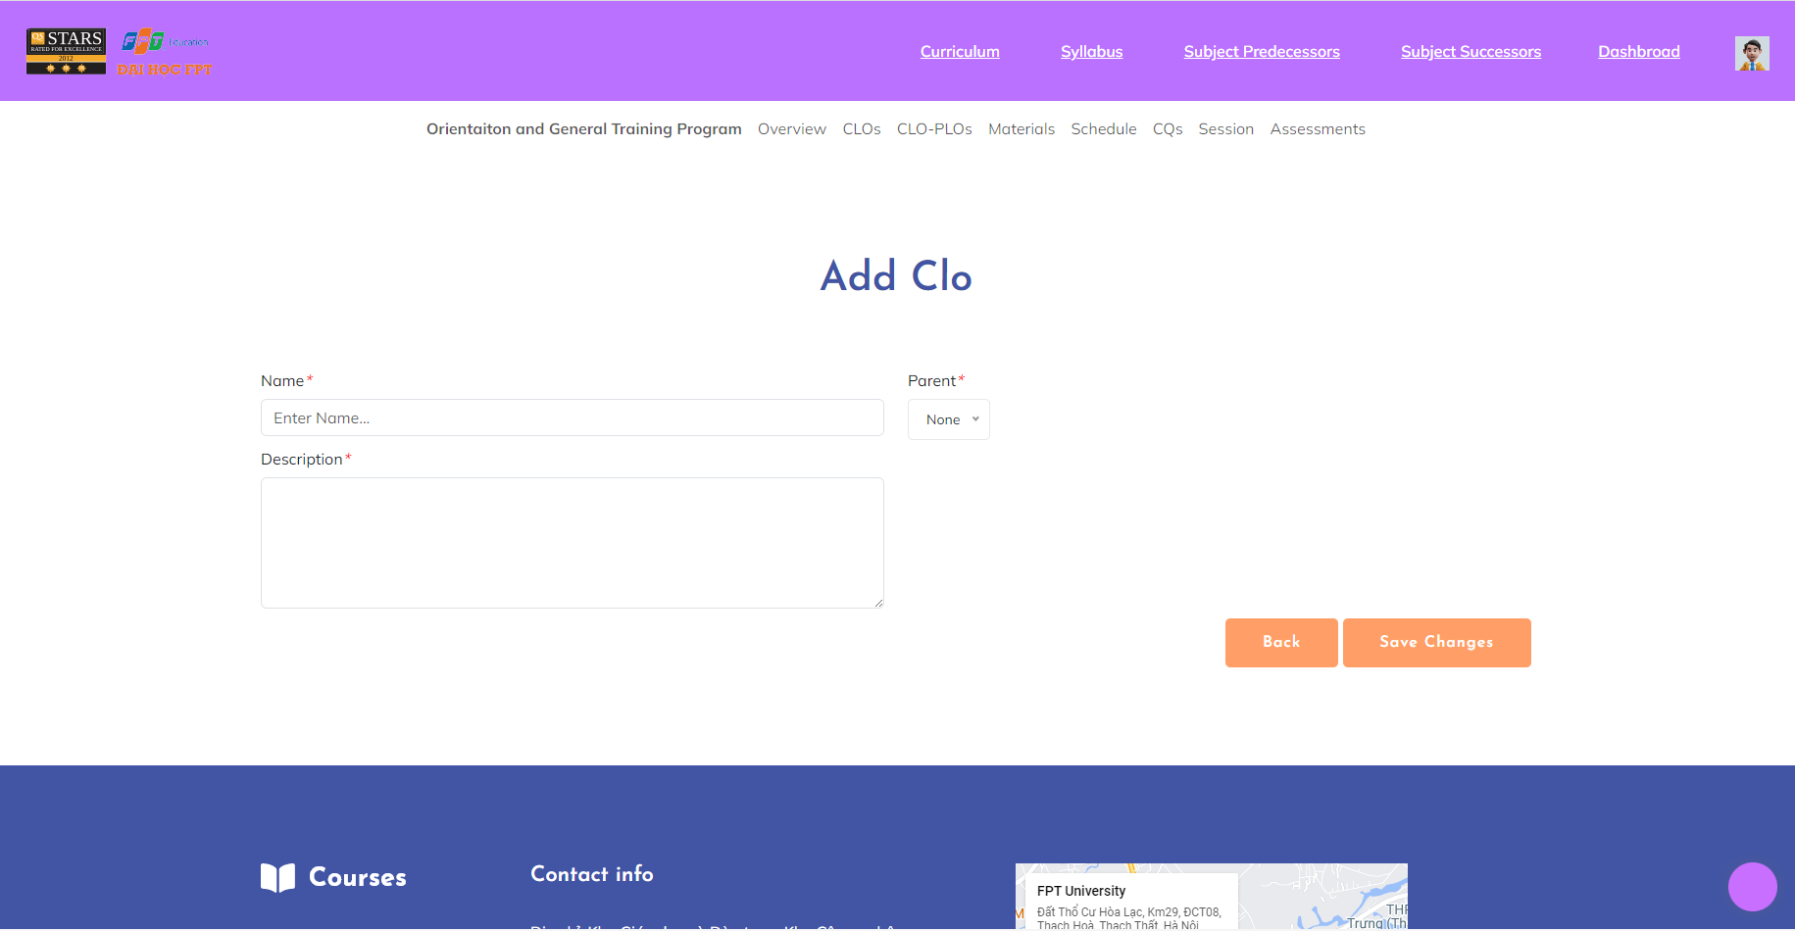

* Edit CLO

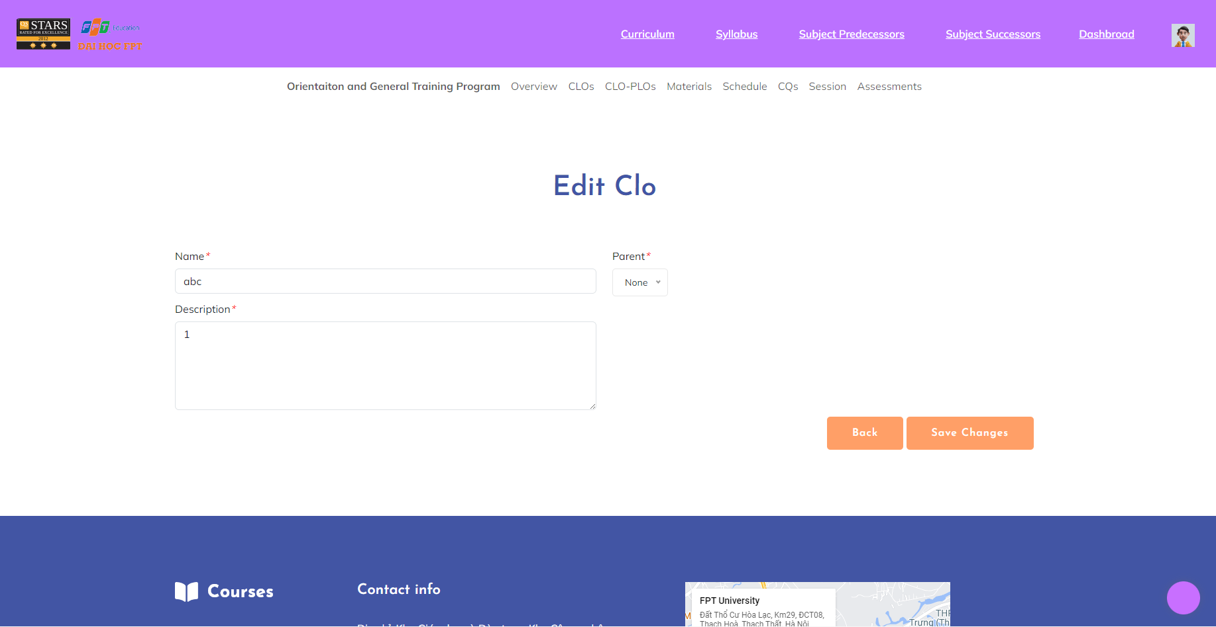

***User Guides***:

* CLO Details
* From the CLO List screen, the admin clicks on the “title” name in the same row as the account he/she wants to view. After viewing, click the “Back” button to go back to CLO List.
* Add CLO
* From CLOList screen, admin click on “Add Clo” button
* After accessing the “Add Clo” screen, admin fill in blank information for new account then click “Save changes” button to finish
* Edit CLO
* From CLO List screen, admin click on icon in the Action column symbol button in the same row as the account he/she wants to edit
* After accessing the “Edit CLO” screen, the admin updates information that needs to change then clicks the “Update” button to update information successfully. If they don’t need to edit this CLO, click the “Back” button to go back to CLO List without changing the CLO details.

**2.3.8. CLO Import**

***Actors***: Syllabus Designer

***Screen/Function Description***: The CLO Import function allows users to import CLO in bulk into the FLM. This function simplifies the process of adding multiple at once, saving time and effort. Users should be able to upload a file Excel containing the CLO data, and the system should validate and process the file to populate the CLO database.

* 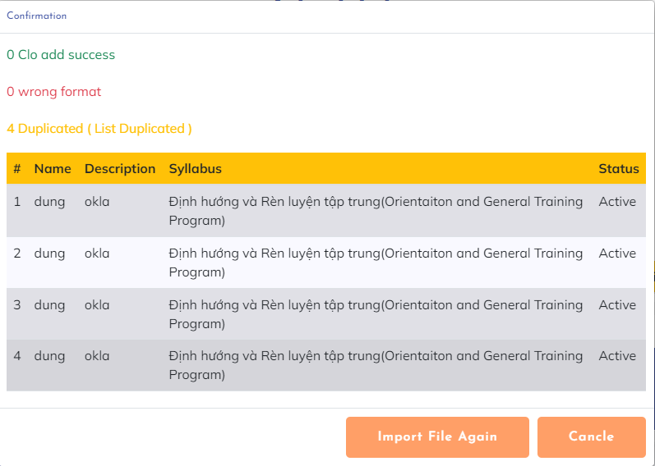

***User Guides***:

* Syllabus Designer click on “Import File” button to open import modal

**2.3.9. CLO-PLO Mapping**

***Actors***: All FLM User

***Screen/Function Description***: CLO-PLO Mapping facilitates the alignment of specific learning outcomes from individual courses to the broader program learning outcomes. It ensures that the content and assessments within each course are designed to support the overall goals and objectives of the educational program.

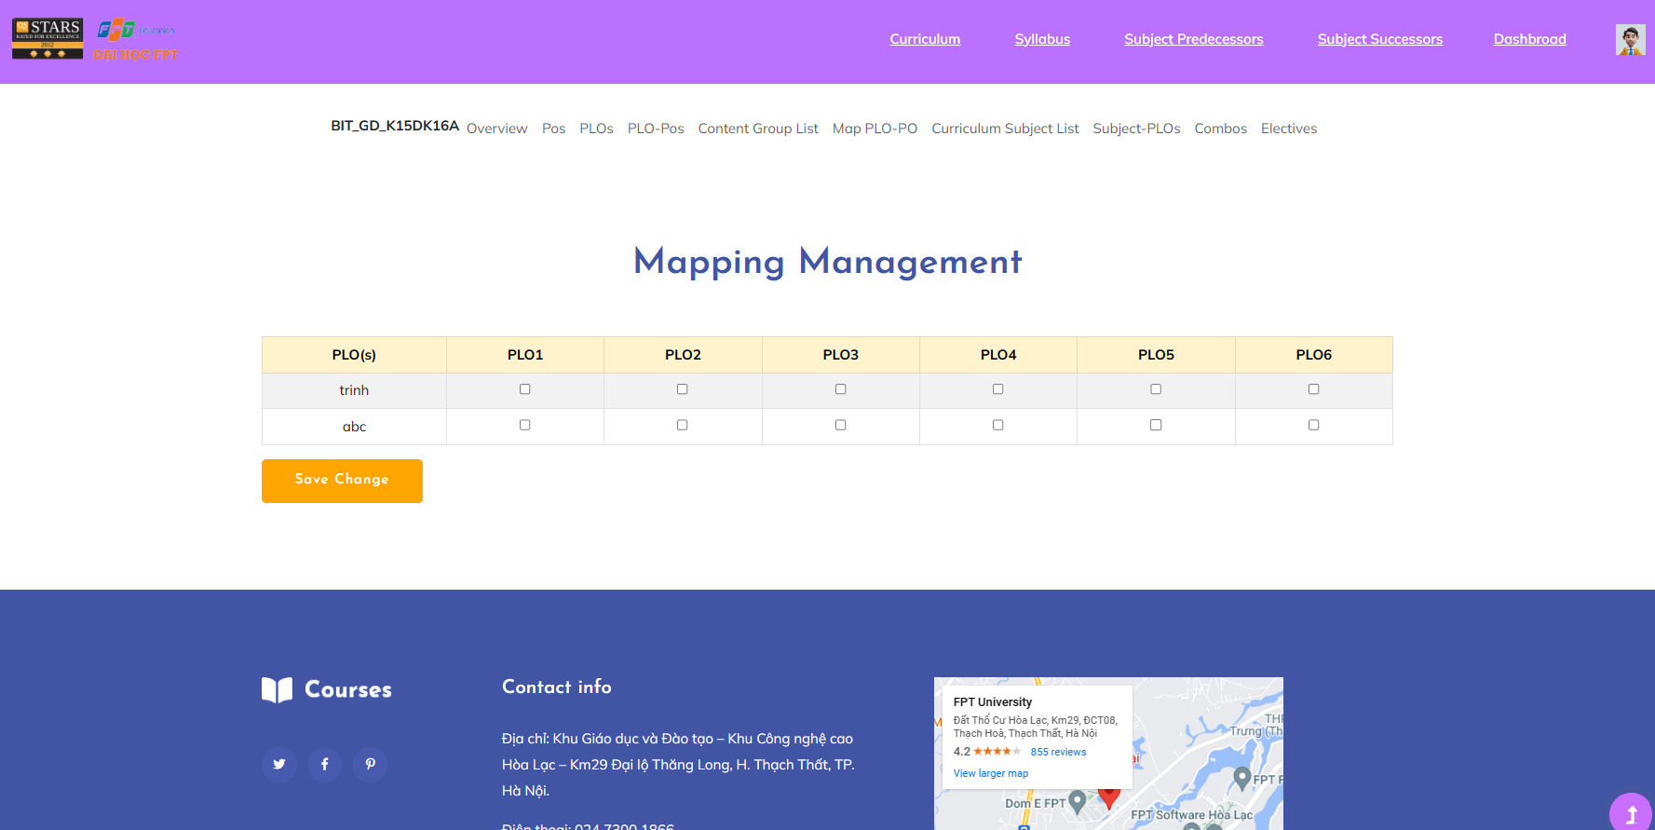

***User Guides***: See mapping of CLO-PLO

**2.3.10. Session List**

***Actors***: All FLM user

***Screen/Function Description***: The session list provides the user with a list of sessions for a particular sylabus that the user has access to

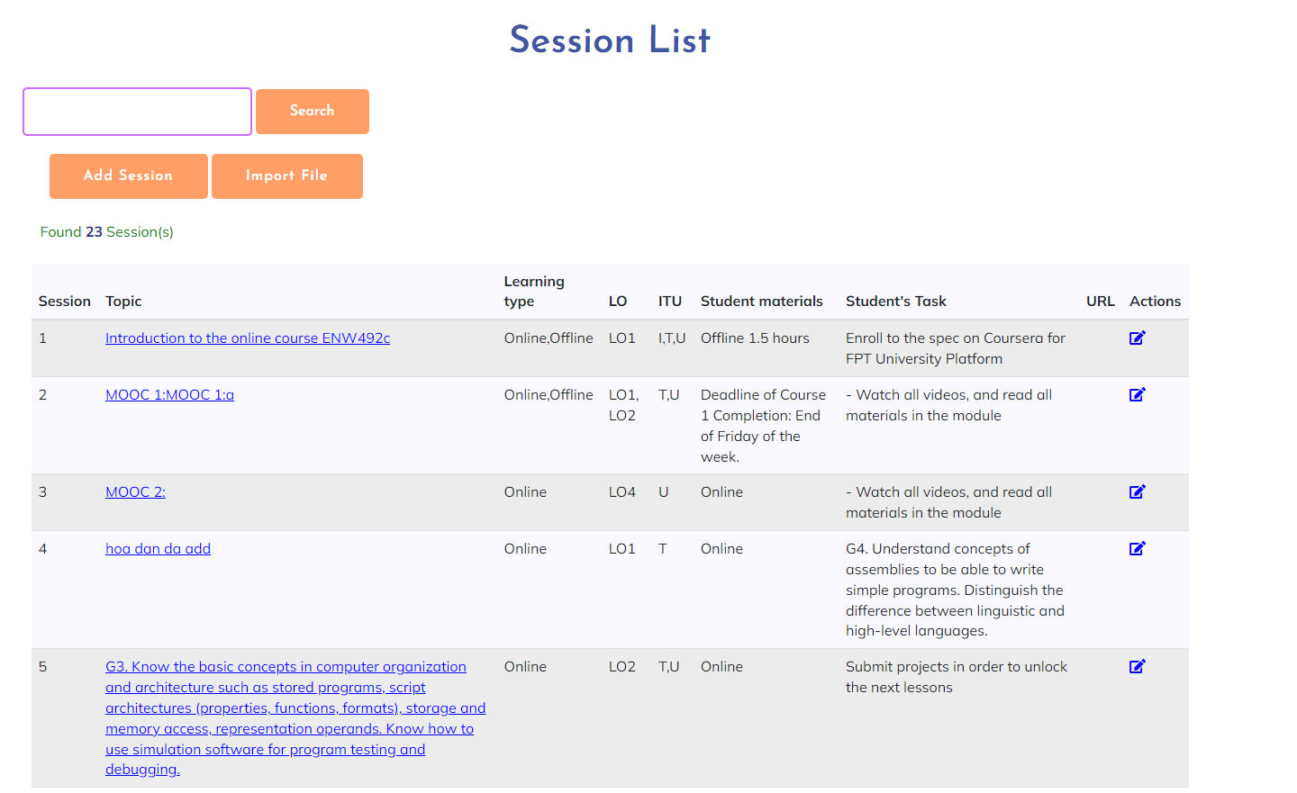

***User Guides***: In the header we can see the syllabus section when the user clicks on the syllabus list in each syllabus there is a link to the syllabus details after the user finishes viewing the syllabus detail they can find the session just below the header bar and have the session section click on it to see the session list of that syllabus.

**2.3.11. Session Detail**

***Actors***:All FLM user

***Screen/Function Description***: The Session Details function provides the user with details of how a particular session will happen

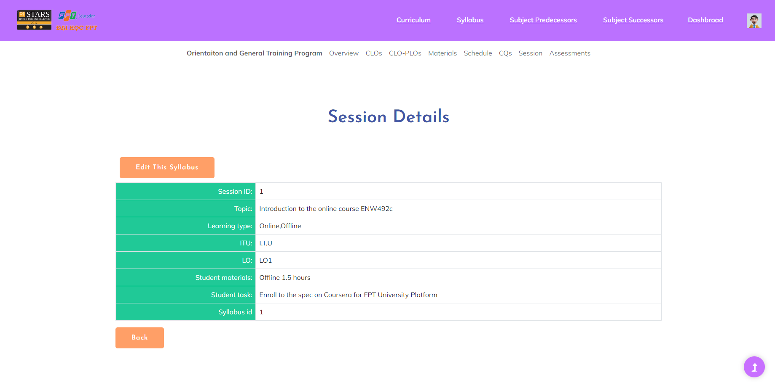

***User Guides***:After the user has access to the list of sessions, each name part of the session is attached a link so that when the user clicks it, it can display the specific details of each session.

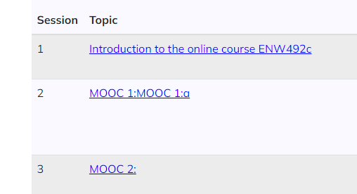

**2.3.12. Session Import**

***Actors***: Syllabus Designer

***Screen/Function Description***: The function import session is a function that helps the administrator to quickly import session data from the outside through the excel file without having to add each session one by one.

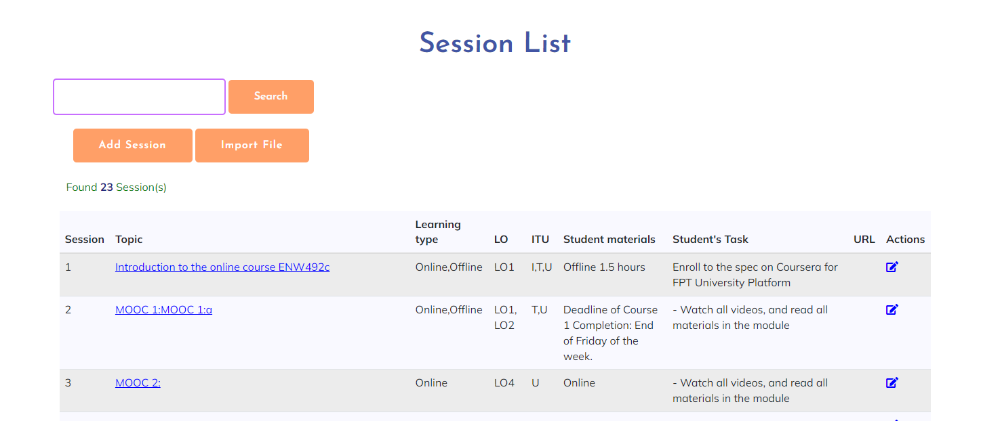

***User Guides***:

When accessing the administrator account, that person will have an additional function to import and add in the session list, just click and download the available excel template and enter it, after entering it will notify how much success or incorrect is.

